Particle Physics

Remember to photocopy 4 pages onto one sheet by going A3→A4 AND back to back on the photocopier

Student name: ________________________________

This booklet contains every higher and ordinary level question that has appeared on an exam paper on this topic from 2002–2023
Worked solutions to Ordinary Level Maths questions can be found at the end of the booklet.
Fully worked solutions to all higher level past papers can be found on the homepage of thephysicsteacher.ie

Screencasts of all topics plus a wide range of other resources via this link

You can find this document plus all other booklets on the homepage of thephysicsteacher.ie
Last updated: 04/08/2024
Noel Cunningham

Contents
Student Notes 2
Cockcroft and Walton build the world’s first particle accelerator 2
Related exam questions 4
Converting other forms of energy into mass: modern particle accelerators 6
The particle zoo 6
Related exam questions 7
Anti-matter 9
Pair production 10
Related exam questions 11
Pair annihilation 13
Related exam question 13
The neutrino 14
Related exam questions 15
Quarks and anti-quarks 16
Related exam questions 17
Fundamental forces of nature 18
SLOP 24
Summary of particle physics maths questions 27
These question are all about energy conversions 27
The energy can take one of four forms: 27
Summary of all four energy conversion equations 28
Sample problems on each of the four energy conversions 29
Linear accelerator 29
Cockroft and Walton experiment 29
Proton-proton collisions 29
Pair production 30
Pair annihilation 30
PARTICLE PHYSICS EXAM QUESTIONS 2002 – 2022 31
Particle accelerators (including Cockcroft and Walton experiment) 31
Maths questions involving protons colliding in a particle accelerator 34
Pair annihilation 36
Pair production 38
Neutrinos 39
PARTICLE PHYSICS EXAM SOLUTIONS 2002 – 2022 41

charge on electron = 1.6022 × 10^{–19} C
mass of electron = 9.1094 × 10^{–31} kg
mass of proton = 1.6726 × 10^{–27} kg
mass of neutron = 1.6749 × 10^{–27} kg
mass of lithium nucleus = 1.1646 × 10^{–26} kg
mass of helium nucleus = 6.6443 × 10^{–27} kg
mass of alpha-particle = 6.6447 × 10⁻²⁷ kg
speed of light = 2.9979 × 10⁸ m s^{–1}
Planck constant, h = 6.6 × 10^{–34} J s

Student Notes

Cockcroft and Walton build the world’s first particle accelerator
They shared the Nobel Prize for their work on splitting the atom.
Operation
- Protons are produced and released at the top.
- The protons get accelerated across a potential difference of 70000 volts.
- The protons collide with a lithium nucleus, and as a result two alpha particles are produced.
- The alpha particles move off in opposite directions at high speed.
- They then collide with a zinc sulphide screen, where they cause a flash and get detected by microscopes.
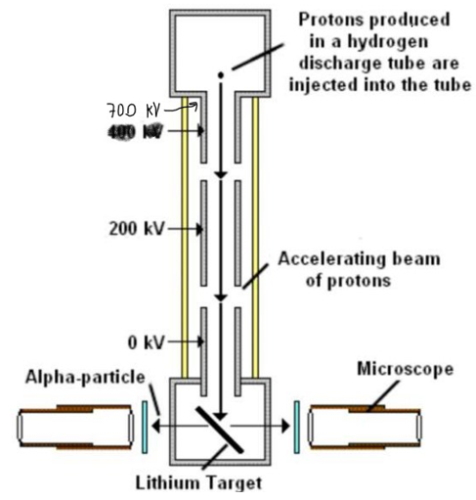

+ → + K.E.
1 MeV 17.3 MeV

Left hand side:
The total mass/energy in consists of the proton plus lithium (plus kinetic energy of the proton of 1 MeV).

Right hand side:
The total mass/energy out consists of the two alpha particles, (plus kinetic energy of the alpha particles of 17.3 MeV).

If we look at the masses of all these particles we see that there is actually less mass afterwards than there was before, despite there being the same number of protons and neutrons on both sides!!!!!
Some of the mass has apparently just vanished; “Curiouser and curiouser”, cried Alice
But, as we can see, there is a lot more kinetic energy afterwards than there was before; could this be a clue?
Turns out that our two heroes guessed that the missing mass was simply turned into kinetic energy.

And they were able to prove it when the value for the missing mass into E = mc² and the E corresponded to the extra kinetic energy. Now that’s impressive.

Why was this experiment significant?
- First artificial splitting of the nucleus.
- First transmutation using artificially accelerated particles.
- First verification of Einstein’s E = mc².
- First particle accelerator

Related exam questions
2009 Question 10 (a)
In 1932 Cockcroft and Walton succeeded in splitting lithium nuclei by bombarding them with artificially accelerated protons using a linear accelerator.
Most of the accelerated protons did not split a lithium nucleus. Explain why.
Solution
The atom is mostly empty space so the protons passed straight through (from Rutherford’s gold foil experiment).

2022 Question 12 [Higher level]
In 1932 Ernest Walton and John Cockcroft verified experimentally Einstein’s equation that relates mass and energy. They accelerated protons through a potential difference of 70 kV before allowing them to collide with lithium metal.
- Draw a labelled diagram of their apparatus.
- Write a nuclear equation for the interaction between a proton and a nucleus of lithium–7.
- The mass of the 1H nuclide is given on page 83 of the Formulae and Tables booklet as1.007825 u.
Convert this mass to kg. (Give your answer to six decimal places.)
- Explain the discrepancy between the value you have calculated and the value given for the mass of the proton on page 47 of the Formulae and Tables booklet.
- Calculate the kinetic energy of the proton as it collided with the metal
- Calculate the mass lost (in kg) during the interaction
- Calculate the energy produced (in J) during the interaction
- Calculate the speed of the alpha particles formed during the interaction.
- A proton may be classified as a hadron. Explain why.
- A proton may also be classified as a baryon. Explain why.
Solution
- Draw a labelled diagram of their apparatus
- hydrogen discharge tube
- linear accelerator with voltage applied correctly
- target [at 45°]
- screen/scintillations/microscope

- Write a nuclear equation for the interaction between a proton and a nucleus of lithium–7.
+ → + K.E.

- Convert 1.007825 u to kg. (Give your answer to six decimal places.)
u = 1.6605402×10^{–27} kg.
(1.007825)(1.6605402×10^{–27}) = 1.673534×10^{–27} kg
- Explain the discrepancy . . .
This one is nuts. Page 83 lists the nuclides. Nuclides are atoms which are listed by their mass number (A) and the atomic number (Z) and because they are atoms they also include the mass of the electrons.
So a ‘1H nuclide’ is a hydrogen atom which has a mass number of 1, so 1 proton and no neutron – but because it’s a nuclide the mass includes the mass of the associated electron! There is nothing on the syllabus (that I am aware of) that suggest that students need to be aware of this. The other source of confusion is the word ‘nuclide’ sounds similar to ‘nucleus’ and could lull some students into confusing one with the other. At least that’s what happened to me.

- Calculate the kinetic energy of the proton as it collided with the metal
kinetic energy of proton at the end = potential energy of the proton at the start
= QV
= (1.60217653×10^{–19})(70000)
= 1.12152357×10^{–14} J
- Calculate the mass lost (in kg) during the interaction
Mass lost = [total mass at the beginning] – [total mass at the end]
= [mass of proton + lithium] – [mass of 2 helium nuclei]
= [7.016005 + 1.007825] – [2(4.002603)]
= 0.018624 u
(0.018624)(1.6605402×10^{–27}) = 3.09259007×10^{–29} kg
- Calculate the energy produced (in J) during the interaction
E = mc²
(3.09259007×10^{–29})(2.99792458 × 10⁸)² = 2.77948134 × 10^{–12} J

- Calculate the speed of the alpha particles formed during the interaction.
The energy ‘produced’ (2.77948134 × 10^{–12} J) takes the form of kinetic energy of the alpha particles moving off afterwards
kinetic energy = ½mv²
2.77948134 × 10^{–12} J = ½(mass of 2 alpha particles) v²
2.77948134 × 10^{–12} J = ½(2)(6.6446565×10^{–27})v²
v = 2.05 × 10⁷ m s^{–1}

- A proton may be classified as a hadron. Explain why.
it experiences the strong force / it is composed of quarks (we will cover this later in this chapter).

- A proton may also be classified as a baryon. Explain why.
baryons are composed of three quarks (we will cover this later in this chapter).

Converting other forms of energy into mass: modern particle accelerators

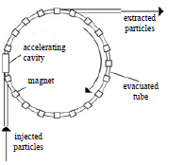
Nowadays the particle accelerators are much more powerful, and one of the more common experiments occurs when physicists bash two protons off of each other.

To do this they are sent in opposite directions (the protons, not the physicists) around a circular particle accelerator at speeds approaching the speed of light.
The accelerators use very large magnetic fields to increase the kinetic energy of the protons; the work done by the magnetic fields corresponds to the gain in kinetic energy of the protons.

Upon collision the protons stop moving and their kinetic energy gets transformed into new and exotic particles {we mean ‘exotic’ in the sense that they are unusual and maybe exciting, not that the particles wear skimpy clothes and go pole-dancing.
$p^{+}$ + $p^{+}$ + kinetic energy = $p^{+}$ + $p^{+}$ + new particles (+ kinetic energy)

The more kinetic energy protons have at the moment of collision, the greater will be the mass (and variety) of new particles produced.

The particle zoo
Most of the particles created in these collisions were new to science and together they became known as the particle zoo.

Related exam questions

Recommended approach: Write an equation to represent what is happening each time, whether you are asked to or not

2009 Question 10 (a)
In the Large Hadron Collider two beams of protons collide producing new particles. Each proton in the beams has a kinetic energy of 2.0 GeV.
What is the maximum net mass of the new particles created per collision?

Solution
The maximum mass that can be created would occur if all of the kinetic energy was converted into mass.

$p^{+}$ + $p^{+}$ + kinetic energy = $p^{+}$ + $p^{+}$ + new particles
Total energy = 4 GeV
G = giga = ×10⁹
So 4 GeV of kinetic energy has been converted into mass energy.
How much mass? We need to use E = mc² to find out.
But before we do that we first need to convert the 4 GeV into joules.
1 eV = 1.6×10⁻¹⁹ joules
4 GeV = (4×10⁹) (1.6×10⁻¹⁹) =6.4×10⁻¹⁰ joules

E = mc² ⇒ $m=\frac{E}{c^{2}}= \frac{6.4 ×{10}^{-10}}{{(2.9979 × 10}^{8)2}}$ ⇒ mass = 7.121×10⁻²⁷ kg

2020 Question 10
In an experiment in Fermilab two protons, each with a kinetic energy of 29 GeV, collide and new particles are created.
After the collision, the total kinetic energy of the two protons and the new particles is 16 GeV.
Calculate the total mass of the new particles created.

Solution
$p^{+}$ + $p^{+}$ + kinetic energy = $p^{+}$ + $p^{+}$ + new particles + kinetic energy (of new particles)

Before the collision each proton has a kinetic energy of 29 GeV, so the total kinetic energy beforehand was 58 GeV. Afterwards it was 16 GeV. So 42 GeV of kinetic energy has been converted into mass energy.

$p^{+}$ + $p^{+}$ + 58 GeV = $p^{+}$ + $p^{+}$ + new particles + 16 GeV

How much mass gets created? We need to use E = mc² to find out.
But before we do that we first need to convert the 42 GeV into joules.
42 GeV = (42×10⁹)(1.6×10⁻¹⁹) = 6.72 × 10⁻⁹ joules.

E = mc² $m=\frac{E}{c^{2}}=\frac{{6.72 × 10}^{-9}}{({{3 × 10}^{8)}}^{2}}$ = 7.48×10⁻²⁶ kg.

2011 Question 10 (a)
In the Large Hadron Collider, two protons with the same energy and travelling in opposite directions collide. Two protons and two charged pi mesons are produced in the collision.
- Write an equation to represent the collision.
- Show that the kinetic energy of each incident proton must be at least 140 MeV for the collision to occur.

Solution
- Write an equation to represent the collision.
$p^{+}$ + $p^{+}$ + kinetic energy = $p^{+}$ + $p^{+}$ + $π$⁺ + π⁻ + kinetic energy
- Show that the kinetic energy of each incident proton must be at least 140 MeV for the collision to occur.
We need to find out how much energy is required to produce {just} two pions {with no kinetic energy}.
So we will be using E = 2m_{π}c² where m_{π} represents the mass of one pion.

$p^{+}$ + $p^{+}$ + kinetic energy = $p^{+}$ + $p^{+}$ + $π$⁺ + π⁻

Mass of a charged pion can be found on page 48 of formulae & tables booklet, but it’s only given relative to the mass of an electron so now we need to go back to page 46 to find the mass of an electron.

Mass of π⁺ = (273)(m_{e)} = 273(9.109×10⁻³¹ kg) = 2.4869×10⁻²⁸ kg

E = 2m_{π}c²
E = 2(2.4869×10⁻²⁸)(3×10⁸)² = 44.76 ×10⁻¹² J

We now need to convert this to eV. 1 eV = 1.602 ×10⁻¹⁹ joules, so we need to divide our number in joules by 1.602 ×10⁻¹⁹ to get the equivalent value in eV.
$$E=\frac{44.76×{10}^{-12}}{1.602×{10}^{-19}}= 279.94 ×{10}^{6} eV ≈ 280 MeV$$

This is the total kinetic energy associated with two protons, so the kinetic energy of each proton must be 140 MeV.

Antimatter
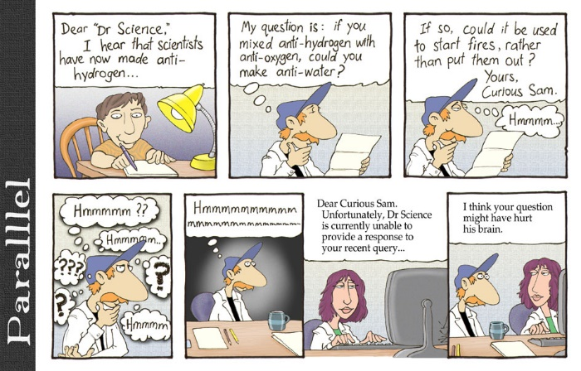
Anti-matter has the same mass as ordinary matter but opposite charge.

Each particle has its own anti-particle. So for example the anti-electron (known as a positron) has the same mass as an electron but has a positive charge.

The English physicist Paul Dirac predicted anti-matter mathematically before it was detected experimentally. Clever boy.

Related exam question
2014 Question 11 (a)
A carbon–11 nucleus decays with the emission of a positron.
Write a nuclear equation to represent the decay of carbon–11.

Solution
Remember beta decay (where a neutron decays into an electron and a proton)?
We represented this with the following nuclear equation: ${}_{0}^{1}n→{}_{1}^{1}{p+{}_{-1}^{0}e}$

An example of beta decay is the following: ${}_{27}^{60}{Co}→{}_{28}^{60}{Ni}+{}_{-1}^{0}e$

This question involves what is known as beta-positive decay, where instead of a neutron decaying into a proton plus electron (beta-minus decay), we have a proton decaying into a neutron plus a positron. Physicists must have done some serious head-scratching the day that baby was born. Technically there is no indication this is on the syllabus. Then again, technically there is no indication that it isn’t.
We approach this as follows: $c_{6}^{11}→{}_{?}^{?}X+{}_{+1}^{0}e$ Therefore $c_{6}^{11}→ B_{5}^{11}+ e_{+1}^{0}$

More on beta-positive decay

Pair production

Pair production occurs when a particle and its antiparticle are produced from a gamma ray photon.
gamma ray photon (γ) → e⁻ + e⁺ + kinetic energy

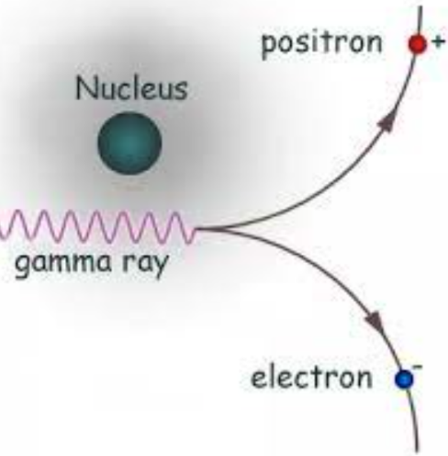
Remember from the chapter on the electron that the energy associated with a gamma ray photon is given by E = hf

where f is the frequency of the wave and
h = Planck’s constant (6.626 × 10⁻³⁴)

Therefore mathematically we can look at the energy of both sides as follows:
$hf= m_{electron}c^{2}+m_{positron}c^{2}$+ kinetic energy

Note:
- Conservation of charge
A photon has no charge and the net charge before and the net charge of the electron and positron after is zero.

- Conservation of momentum
The gamma ray photon does have momentum! So for momentum to be conserved, there must be momentum afterwards, therefore the two new particles cannot move off in opposite directions.

- Kinetic energy represents the kinetic energy of the electron and positron as they move off.

- Pair production can only occur if the photon has an energy greater than twice the mass of the electron.

- Why do we need the nucleus?

Question: Did you know that photons have mass?
Answer: I didn’t even know they were Catholic.

Related exam questions
2013 Question 5 [Higher level]
Give an expression for the minimum frequency of a photon that can form an electron and a positron by pair production.
Solution
We need to have an expression for the energy associated with a photon (in joules) and the energy associated with the mass of the electron and positron (in joules) and then just equate them.

energy of photon = energy of electron plus energy of positron
$$hf= m_{electron}c^{2}+m_{positron}c^{2}$$

but an electron and a positron have the same mass.
Therefore hf = 2mc² $f= \frac{2mc^{2}}{h}$

2003 Question 10 (a)
The following reaction represents pair production: γ → e⁺ + e–
- Calculate the minimum frequency of the γ-ray photon required for this reaction to occur.
- What is the effect on the products of the reaction if the frequency of the γ-ray photon exceeds the minimum value?

Solution
- The energy associated with the gamma ray photon (hf) needs to be equal to the energy associated with 2 electrons (2mc²)
hf = 2mc²

(6.6 × 10^{–34})(f) = 2(9.1 × 10^{–31})(3.0 × 10⁸)²

f = 2.5×10²⁰ Hz

- If the frequency exceeds the minimum value then the newly-created particles will move off with kinetic energy (and/or more massive particles will be created).
2021 Question 13 (a) [Higher Level]
A photon produces a muon anti‐muon pair. Calculate the minimum energy of the photon in electronvolts.
Solution
energy of photon = energy of muon plus energy of anti-muon
$$= m_{muon}c^{2}+m_{anti-muon}c^{2}$$

The mass of a muon can be found on page 48 of formulae & tables booklet, but it’s only given relative to the mass of an electron so now we need to go back to page 46 to find the mass of an electron.
m = mass of 2 muons = Two times the mass of one muon = (2)(2.07×10²)(9.109×10^{–31})
= 3.769 ×10^{–28} kg

{Note the marking scheme gives the mass of the muon as 206.9 times the mass of the electron.
I have no idea where they get that number from. The formulae and tables book gives the mass of the muon to be 2.07×10² times the mass of the electron (or 207), not 206.9}

E = 2(m_{μ})c² = (2)(3.769 ×10^{–28})(3.0 × 10⁸)² = 3.388 × 10^{–11} J

We now need to convert this to eV. $E=\frac{3.388×{10}^{-11}}{1.602×{10}^{-19}}$ = 2.115 × 10⁸ eV

2010 Question 10 (a)
A photon of frequency 3.6 × 10²⁰ Hz causes pair production.
Calculate the kinetic energy of one of the particles produced, each of which has a rest mass of 9.1×10^{–31} kg.

Solution
gamma ray photon (γ) → (particle + anti-particle) + kinetic energy of particles
hf = 2[mc²] + kinetic energy of particles

hf = (6.6 × 10⁻³⁴)( 3.6 × 10²⁰) = 2.376 × 10⁻¹³ J

Energy required to produce the two particles = 2[mc²]
E = 2(9.1 × 10⁻³¹)(3.0 × 10⁸)² = 1.638 × 10⁻¹³ J

Energy of incident photon = energy required to create 2 particles + kinetic energy of particles
2.376 × 10⁻¹³ J = 1.638 × 10⁻¹³ J + kinetic energy of particles

kinetic energy of particles = (2.376 × 10⁻¹³) – (1.638 × 10⁻¹³) = 7.38 × 10⁻¹⁴ J

Kinetic energy per particle is half of this = 3.69 × 10⁻¹⁴ joules

Pair production – toast style

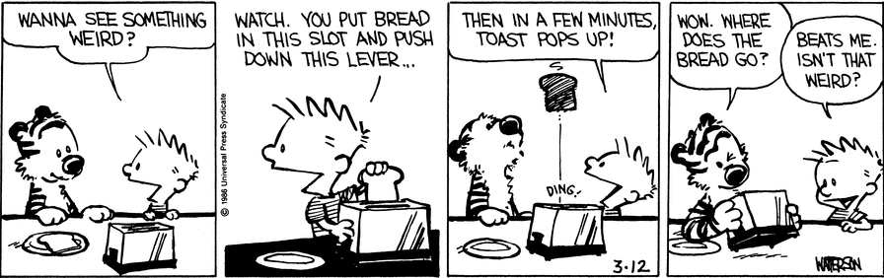
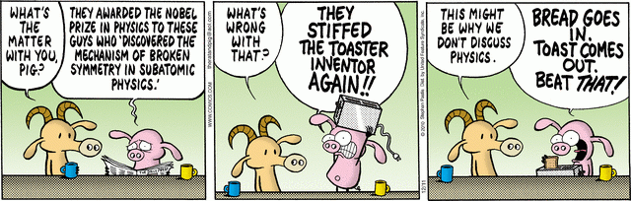

Pair annihilation
An electron and a positron collide to produce two gamma ray photons
$$e^{+}+e^{- }+kinetic energy→2γ$$

2$m_{e}$c² + kinetic energy → 2hf
Mathematically we can look at the energy of both sides as follows:
Note:
- Conservation of charge
Net charge before and after is zero.

- Conservation of momentum
For momentum to be conserved you must note that the electron and positron are moving directly towards each other beforehand, therefore in order for there to be no (net) momentum afterwards, the two photons produced must fly off in opposite directions (which is why we need two photons).

- You must use the phrase ‘gamma-ray photons’, and not just ‘photons’; the logic being that ‘gamma-ray’ implies a very high level of energy!

Related exam question

2012 Question 10 (a)
When a positron and an electron meet two photons are produced.
- Write an equation to represent this interaction.
- Calculate the minimum frequency of the photons produced.
- Explain why the photons produced usually have a greater frequency than your calculated minimum frequency value.

- Write an equation to represent this interaction.
‘minimum frequency’ implies that there is no kinetic energy beforehand
e⁻ + e⁺ → 2hf OR ${}_{-1}^{0}{e+ {}_{+1}^{0}{e →2γ}}$
- Calculate the frequency of each photon produced in this pair annihilation.
2$m_{e}$c² → 2hf OR $m_{e}$c² → hf
$f= \frac{mc^{2}}{h}$ $f= \frac{{9.1093826 × 10}^{-31}({3×{10}^{8)}}^{2}}{{6.6260692×10}^{-34}}$ f = 1.237 × 10²⁰ Hz

Explain why the photons produced usually have a greater frequency than your calculated minimum frequency value.
Because the positron and electron are likely to have kinetic energy before they meet, which we didn’t consider for this question.

The neutrino
Right now approximately ten trillion neutrinos (coming from the Sun) are passing through your hand every second. And it doesn’t even matter which hand – or that you have no idea what ten trillion means.

The neutrino was first postulated by the Austrian physicist Wolfgang Pauli (of Pauli’s Exclusion Principle fame) to account for the apparent discrepancy between the momentum before and after beta decay (remember this happens when a neutron splits into a proton and an electron).

The symbol for a neutrino is $v$

$$n_{0}^{1}→p_{1}^{1} {+e}_{-1}^{0}+v+kinetic energy$$

The term neutrino was itself coined by the Italian physicist Enrico Fermi.
The neutrino is extremely small, has almost no mass and has no charge (the term itself means ‘little neutral one’).

2008 Question 5
The existence of the neutrino was proposed in 1930 but it was not detected until 1956.
Give two reasons why it is difficult to detect a neutrino.
Solution
Neutrinos have no charge and very small mass.
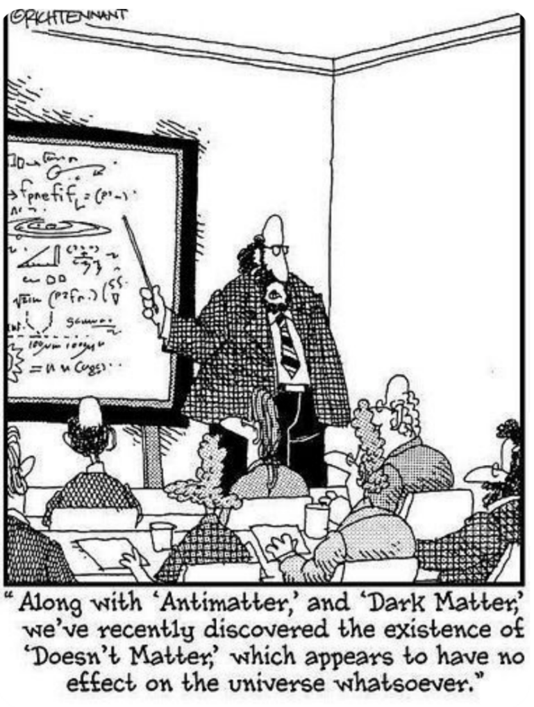

Related exam questions
2015 Question 10 (a)
- Write a nuclear equation to represent beta-decay.
- Calculate the energy released, in MeV, during beta-decay.

Solution
- Write a nuclear equation to represent beta-decay.
You must include the neutrino:
$$n_{0}^{1}→H_{1}^{1} {+e}_{-1}^{0}+v+kinetic energy$$

- Calculate the energy released, in MeV, during beta-decay.
Like the previous questions we need to find the total mass beforehand and the total mass afterwards and then subtract to find the mass/energy that was converted to kinetic energy.

You need to use pages 46, 47 and 48 of the Formulae & Tables book to get values for the masses of the various particles.

Mass of neutron: 1.674 927 28 × 10⁻²⁷ kg Mass of proton: 1.672 621 71 × 10⁻²⁷ kg
Mass of electron: 9.109 3826 × 10⁻³¹ kg
Mass of neutrino: see page 48
The mass of the neutrino is given relative to the mass of an electron.
Mass of neutrino = (4.305 × 10⁻⁶)(9.109 3826 × 10⁻³¹) = 3.921589209 × 10⁻³⁶ kg

Mass before = mass of neutron= 1.674 927 28 × 10^{–27} kg

Mass after = mass of proton + mass of electron + mass of neutrino
= 1.672 621 71 × 10⁻²⁷ kg + 9.109 3826 × 10⁻³¹ kg + 3.921589209 × 10⁻³⁶ kg

Total mass after = 1.673532652 × 10⁻²⁷ kg

Loss in mass = total mass beforehand – total mass afterwards
= (1.674 927 28 × 10^{–27} kg) – (1.673532652 × 10⁻²⁷ kg) = 1.395 × 10^{–30} kg

To calculate the energy associated with this mass we need to use E = mc²
E = (1.395 × 10^{–30})(2.997 924 58)² E = 1.25 × 10⁻¹³ J

Now we need to convert from Joules to eV
1 eV = 1.602 176 53 × 10⁻¹⁹ J {page 46 of Formulae & tables book}

So we need to divide 1.25 × 10⁻¹³ by 1.602 176 53 × 10⁻¹⁹ E = 780188 eV
Now divide by 1×10⁶ to convert to MeV {M = mega = 10⁶} E = 0.78 MeV

Quarks and anti-quarks
It turns out that many particles which we thought to be fundamental are actually made up of more fundamental particles, called quarks.
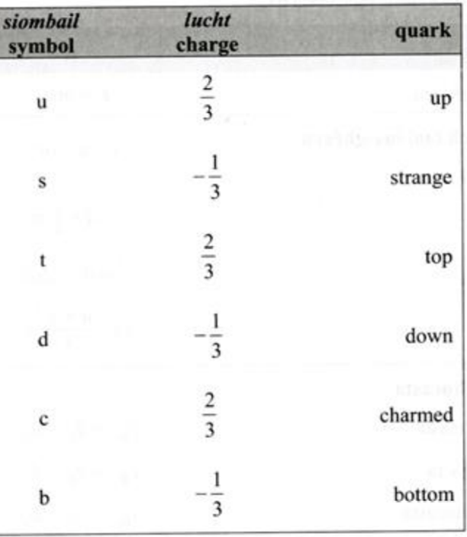
There are six types of quark (see also page 49 of the Formula & Tables book). The charge indicated is given as a fraction of the charge of one electron, e.g. the Up quark has a charge of two thirds the charge of an electron.

Murray Gell-Mann
The term quark was given to these particles by the American physicist Murray Gell-Mann.
He found the word in a book by James Joyce, called Finnegans Wake. You need to know this.

Anti-quarks
An anti-quark has the same mass as its quark counterpart, but opposite charge.
e.g. an anti-up ($\overline{u}$) has a charge of – 2/3 e.

If a particle is composed of three quarks (or three anti-quarks) it is called a baryon and if it is composed of a quark/ antiquark pair it is called a meson.

Particles made from quarks/antiquarks |  |  | Classification
Example | Composition | Charge
Proton | uud | +1 (+2/3, +2/3, -1/3) | Baryon
Neutron | udd | 0 (+2/3, -1/3, -1/3) | Baryon
Pion | ud | +1 (+2/3, +1/3) | Meson

Related exam questions

2018 Question 5  State  (i) a physical quantity that is the same for a quark and its anti‐quark and  (ii) a physical quantity that is different for a quark and its anti‐quark. | Same: mass and the magnitude of charge  Different: sign of charge
2016 Question 5  What terms are used for hadrons that consist of  (i) two quarks, (ii) three quarks? | (i) Mesons  (ii) Baryons
2015 Question 5  Give the quark composition of  (i) the proton and (ii) the anti-neutron. | - up, up, down  - anti-up, anti-down, anti-down
2011 Question 5  Give the difference between the quark composition of a baryon and of a meson. | Baryon: 3 quarks  Meson: quark and antiquark
2007 Question 5  A kaon consists of a strange quark and an up anti-quark. What type of hadron is a kaon? | The clue is the fact that the particle is composed of a quark and an antiquark.  It is therefore a meson.
2006 Question 5  Name the three negatively charged leptons. | Electron (e) , muon (μ), tau (τ )  {See page 48 of the Formula & tables book}
2004 Question 5  Give the quark composition of the neutron. | Up, down, down.
Pions are mesons that consist of up and down quarks and their antiquarks. Give the quark composition of  (i) a positive pion, (ii) a negative pion. | π⁺ = up and anti-down  π⁻ = down and anti-up
List the six flavours of quark. | Up, down, strange, charm, top and bottom.
A member of a meson family consists of two particles. Each particle is composed of up and down quarks and their anti-particles.  Construct the possible combinations and deduce the charge of each combination.
  composition |  | charge
  u + | $$\overline{u}$$ | 0
  u + | $$\overline{d}$$ | +1
  d + | $$\overline{u}$$ | -1
  d + | $$\overline{d}$$ | 0

Fundamental forces of nature

Happily (hah!) we can categorise all particles on the basis of their composition and the forces they are subject to. There are actually only four fundamental forces in nature.
But how can this be? Surely there are dozens of different forces?
The four forces (in decreasing order of strength):
- Strong nuclear force
- Electromagnetic force
- Weak nuclear force
- Gravitational force
Think “Steady Effort Wins Games”.

2009 Question 5
Arrange the fundamental forces of nature in increasing order of strength.
Solution
Gravitational, weak, electromagnetic, strong.

Force | Role | Range
Strong nuclear force | Binds nucleus together | Short
Electromagnetic force | Force between charged particles | Inverse square law
Weak nuclear force | Responsible for Beta decay | Short
Gravitational force | Force between planets | Inverse square law

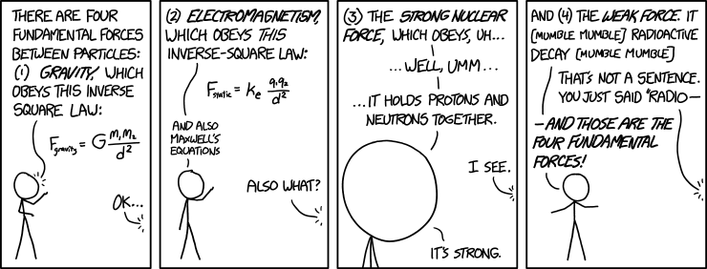

http://xkcd.com/1489/
Everything on one map – this you need to know

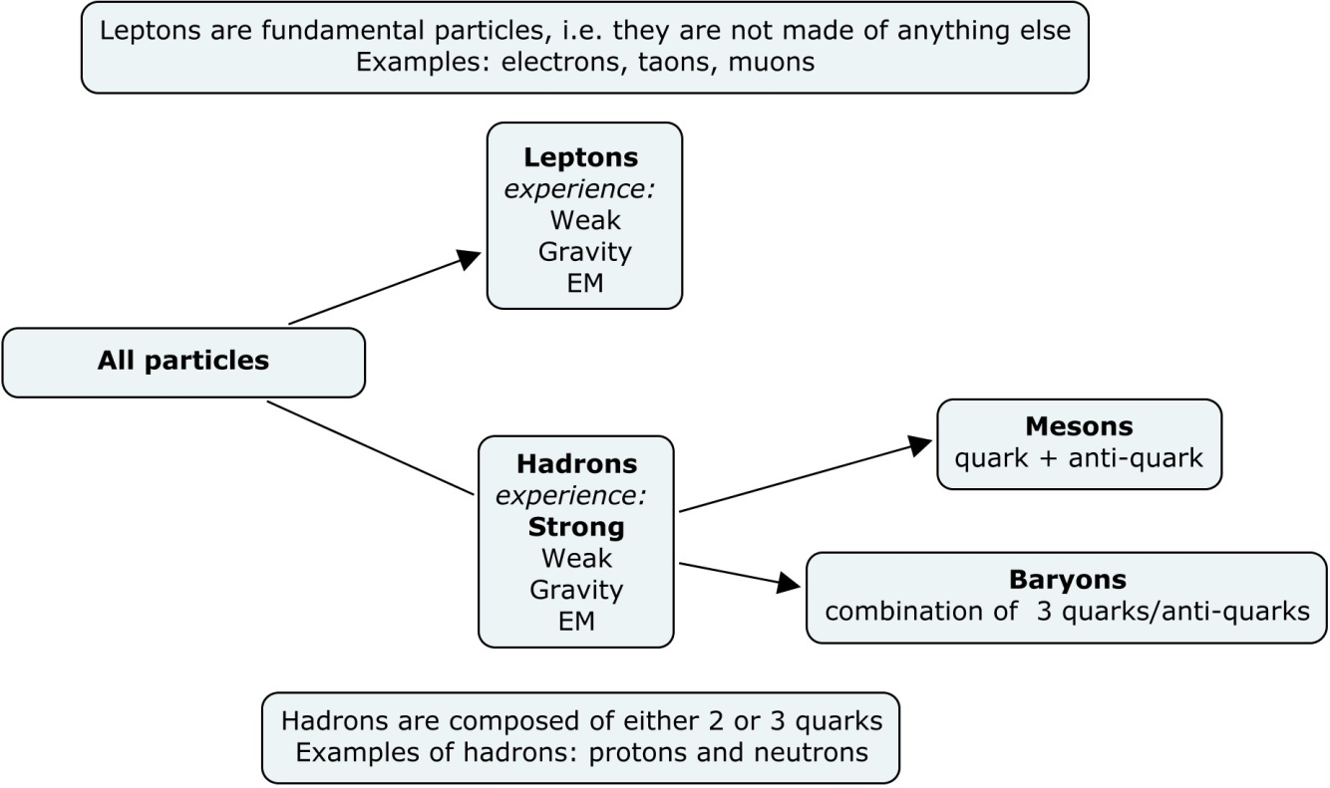
All fundamental particles can now be categorised as follows

Leptons: Indivisible point objects not subject to the strong nuclear force, e.g. positron, electron, muon, tao, neutrino.

Hadrons: Feel all four forces. Hadrons can be further sub-divided into mesons and baryons.

Mesons: Subject to all forces; mass between electron and proton; composed of a quark and an anti-quark, e.g. the pion

Baryons: Subject to all forces; composed of 3 quarks or 3 anti-quarks, e.g. the proton and the neutron.

Because a quark is composed of a quark and an anti-quark (matter and anti-matter) it annihilates almost immediately.

Any time you refer to the gravitational force as part of an answer you must use exactly that term, i.e. you must say ‘gravitational force’ and not ‘gravity’.

Similarly, you should refer to the ‘strong nuclear force’ rather than the ‘strong force’.

This you do NOT need to know but the VERY important point is that while we can show mathematically how each of the strong, weak and electromagnetic forces are all inter-related, we have ABSOLUTELY no way of connecting the gravitational force with any of the other three.
It is considered by many to be one of the greatest mysteries in all of science.
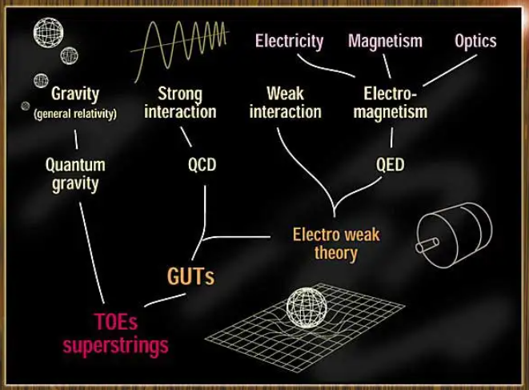

Link

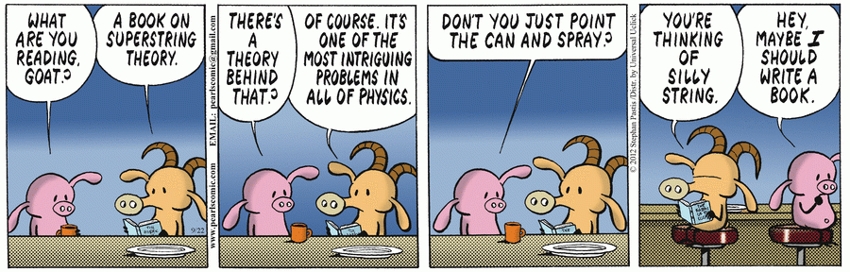
Superstring theory


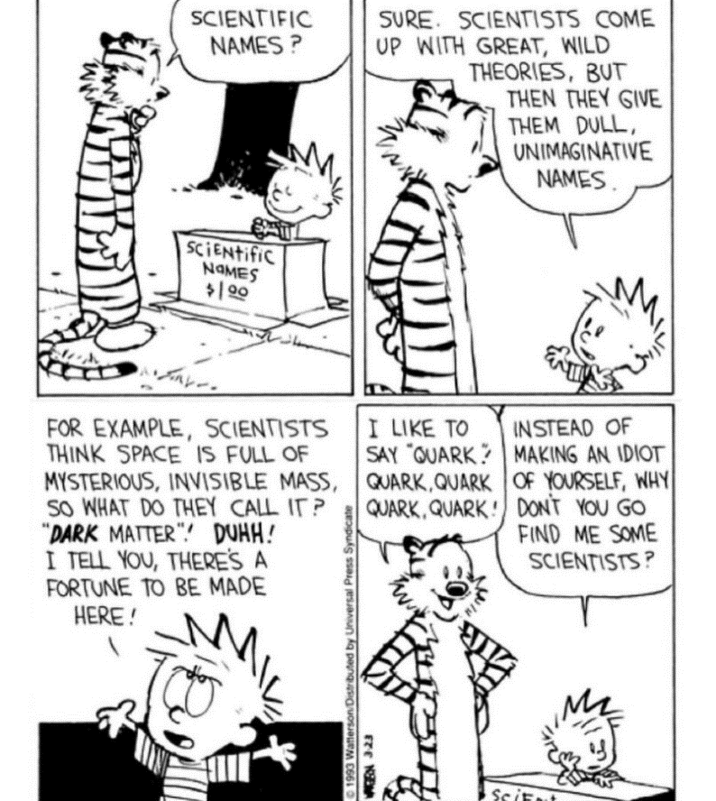

Background reading

The neutrino
We have seen that in beta decay, a neutron breaks up in to a proton and an electron.
The equation is n⁰ → p⁺ + e⁻

However when scientists investigated the momentum before and after, they noticed something strange.
The momentum after was a little less than the momentum beforehand, and no matter how many times they repeated the experiment they got the same result.
It was as if there was something missing on the right hand side, but they couldn’t find anything. It was all very confusing.
Picture the situation:
A certain amount of energy and momentum go into the equation, but not enough comes out.
Up steps a well-known Italian scientist called Wolfgang Pauli to suggest that there actually is more momentum coming out, but the reason that it is not detected is because it comes in the form of particles which have no charge, and whose mass is too small to be detected.
It’s kinda hard to be proved wrong in that one!
Pauli coined the name ‘neutrino’ for the particle because it means ‘little neutral one’ in Italian.
By the way, this is indeed the same Pauli of ‘Pauli’s Exclusion Principle’ fame, which those of you sad enough to be doing Chemistry will recognise.

To give an idea of how radical a prediction this is, remember that all good science is supposed to be built upon the cornerstone of experiments.
If you predict something to exist but that it can never be verified by experiment then you may as well be talking about the existence of God; It’s not to say that God doesn’t exist, it’s just that in science we have to stick to what we can verify by experiment.
Then along comes Pauli and breaks this golden rule.
In fairness, Pauli realised this himself. He admitted, “I have done a terrible thing – I have predicted the existence of a particle which cannot be detected”!

But these were strange times in physics; Ernest Rutherford was probably the foremost physicist alive at this stage (he had, after all, split the atom. Cockcroft and Walton were working under Rutherford when they carried out their groundbreaking experiment).
Rutherford’s advice was to assume that the conservation of energy law probably didn’t apply at this level.

As it turned out, the neutrino was detected experimentally in 1956, although there is still much that remains unknown about this particle.
For instance did you know that somewhere between 90% and 99% of all matter in this universe is unaccounted for?
One possible explanation is that the neutrino is carrying this mass.
While it is obviously very, very, very light, the small mass it does have, multiplied by the sheer (literally?) weight of numbers, may make it the culprit.

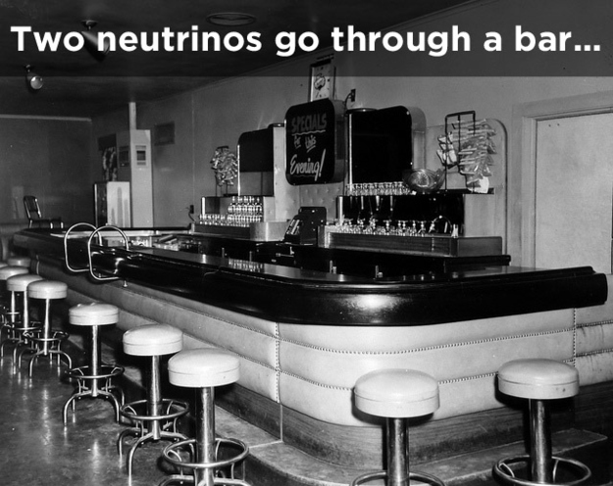
Did you know there are 10¹⁵ neutrinos pass through you every second, coming from the sun?
The fact that at night-time the Earth is between you and the Sun doesn’t matter – these little critters pass straight through the Earth!

Cosmic Gall
Neutrinos, they are very small.
They have no charge and have no mass
And do not interact at all.
The earth is just a silly ball
To them, through which they simply pass,
Like dustmaids down a draughty hall
Or photons through a sheet of glass.
They snub the most exquisite gas,
Ignore the most substantial wall,
Cold shoulder steel and sounding brass,
Insult the stallion in his stall,
And scorning barriers of class,
Infiltrate you and me! Like tall
And painless guillotines, they fall
Down through our heads into the grass.
At night they inter at Nepal
And pierce the lover and his lass
From underneath the bed – you call
It wonderful; I call it crass.

Telephone Poles and Other Poems, John Updike, Knopf, 1960
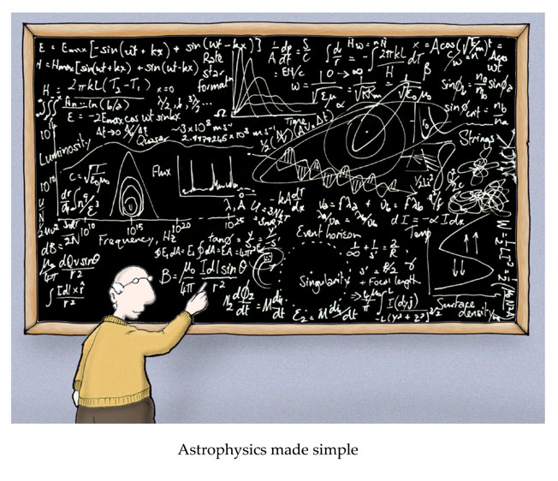

SLOP
mass of proton = 1.6730 × 10⁻²⁷ kg; mass of electron = 9.1 × 10^{–31} kg;
mass of lithium nucleus = 1.1646 × 10⁻²⁶ kg; mass of α-particle = 6.6443 × 10⁻²⁷ kg;
mass of neutron = 1.6749 × 10^{–27} kg; charge on electron = 1.6022 × 10^{–19} C;
mass of pion = 2.4842 × 10^{–28} kg;
speed of light, c = 2.9979 × 10⁸ ms⁻¹; Planck constant = 6.626 × 10⁻³⁴ J s

Particle Accelerators, Cockcroft and Walton Experiment and E = mc²
How were the protons accelerated? | They were accelerated by the very large potential difference which existed between the top and the bottom.
How were the alpha particles detected? | They collide with a zinc sulphide screen, where they cause a flash and get detected by microscopes.
High voltages can be used to accelerate alpha particles and protons but not neutrons.  Explain why. | Alpha particles and protons are charged, neutrons are not.
Most of the accelerated protons did not split a lithium nucleus. Explain why. | The atom is mostly empty space so the protons passed straight through.
Outline the Cockcroft and Walton experiment | See notes
Draw a labelled diagram of the experiment | See notes
Write a nuclear equation to represent the splitting of a lithium nucleus by a proton. | + → + K.E.
Give two advantages of circular accelerators over linear accelerators. | Circular accelerators result in progressively increasing levels of speed/energy and occupy much less space than an equivalent linear accelerator.
In an accelerator, two high-speed protons collide and a series of new particles are produced, in addition to the two original protons. Explain why new particles are produced. | The kinetic energy of the two protons gets converted into mass.
The neutrino
Write a nuclear equation for beta decay. | $$n_{0}^{1}→H_{1}^{1} {+e}_{-1}^{0}+v$$  Note that you must include the neutrino
Give two reasons why it is difficult to detect a neutrino. | No charge and very small mass.
In beta decay it appeared that momentum was not conserved.  How did Fermi’s theory of radioactive decay resolve this? | He realised that another particle must be responsible for the missing momentum, which they called the neutrino.
Antimatter
What is anti-matter? | Antimatter is material/matter/particles that has same mass as another particle but opposite charge.
An anti-matter particle was first discovered during the study of cosmic rays in 1932.  Name the anti-particle and give its symbol. | positron / anti-electron
Compare the properties of an electron with that of a positron. | Both have equal mass / charges equal / charges opposite (in sign) / matter and anti-matter
What happens when an electron meets a positron? | Pair annihilation occurs; and the mass gets converted to energy.
Give one contribution made to physics by Paul Dirac. | Dirac predicted antimatter.
Pair Production
Write a reaction that represents pair production. | gamma ray photon (γ) → e⁻ + e⁺ + K.E.
What is meant by pair production? | Pair production involves the production of a particle and its antiparticle from a gamma ray photon.
Explain how the principle of conservation of charge and the principle of conservation of momentum apply in pair production. | Net charge on both sides is zero  Momentum of positron + electron = momentum of photons
Pair Annihilation
What happens when a particle meets its anti-particle? | Pair annihilation occurs and the mass gets converted to energy.
What is a photon? | A photon is a discrete amount of electromagnetic radiation.
Write a reaction that represents pair annihilation. | e⁺ + e⁻ → 2γ
Explain how the principle of conservation of charge and the principle of conservation of momentum apply in pair annihilation.. | Net charge on both sides is zero  Momentum of positron + electron = momentum of photons
Fundamental Forces
List the four fundamental forces in order of increasing strength.  State the range and give one property of each one. | Strong, electromagnetic, weak, gravitational  See notes for table
List the fundamental forces of nature that pions experience. | Strong, electromagnetic, weak, gravitational
Name the force that holds the nucleus together. | The strong nuclear force
Quark Composition and Particle Classification
What famous Irish writer first thought up the name ‘quark’? | James Joyce
Name the three positively charged quarks. | Up, charm and top
What is the difference in the quark composition of a baryon and a meson? | A baryon is composed of three quarks or three anti-quarks. A meson is composed of a quark + anti-quark.
What is the quark composition of the proton? | Up, up, down
A kaon consists of a strange quark and an up anti-quark. What type of hadron is a kaon? | It is a meson.
Pions are mesons that consist of up and down quarks and their antiquarks.  Give the quark composition of  (i) a positive pion, (ii) a negative pion. | π⁺ = up and anti-down  π⁻ = down and anti-up
Name the three negatively charged leptons. | Electron (e) , muon (μ), tau (τ )
Give the quark composition of the neutron. | Up, down, down
List the six flavours of quark. | Up, down, strange, charm, top and bottom.
Leptons, baryons and mesons belong to the “particle zoo”.  Give (i) an example, (ii) a property, of each of these particles. | LEPTONS; electron, positron, muon , tau, neutrino  Not subject to strong force  BARYONS; proton, neutron  Subject to all forces, three quarks  MESONS pi(on), kaon  Subject to all forces, mass between electron and proton, quark and antiquark
- A member of a meson family consists of two particles. Each particle is composed of up and down quarks and their anti-particles.  Construct the possible combinations. Deduce the charge of each combination and identify each combination.
  composition |  | charge | name
  u + | $$\overline{u}$$ | 0 | Pi-neutrino
  u + | $$\overline{d}$$ | +1 | Pi-plus
  d + | $$\overline{u}$$ | -1 | Pi-minus
  d + | $$\overline{d}$$ | 0 | Pi-neutrino

Summary of particle physics maths questions

These question are all about energy conversions

The energy can take one of four forms:

- It can be potential energy: W = QV
(Q is charge, V is potential difference)
Example: Linear accelerators

- It can be kinetic energy: E = ½ mv²
(m is mass, v is velocity)
Example: Proton-proton collisions

- It can be in the form of electromagnetic radiation where E = hf
(f is frequency, h is Planck’s constant)
Example: Pair production

- It can be in the form of mass, in which case the energy equivalent is E = mc²
(m is mass, c is the speed of light)
Example: Large Hadron Collider, Pair annihilation

The context will determine which of the above equations you will need

Notes
- Make sure you can convert from electron-volts (eV) to joules (J) and vice-versa
(1eV =1.6 x 10^{–19} joules)

- Be comfortable dealing with very large numbers and very small numbers on your calculator.
Be comfortable using the Formulae & Tables book to find all relevant information, particularly the mass of the particles.
In particular note that page 47 and page 83 are the most used pages.
Note also that on page 83, masses of nuclei are given in terms of the atomic mass unit (u).
You then need to go to page 47 to find the mass of one atomic mass unit.

Summary of all four energy conversion equations

Linear Accelerator
potential energy → kinetic energy
QV → ½ mv²

Cockroft and Walton experiment
Some of the mass beforehand disappears and is converted into kinetic energy of the new particles
mass → kinetic energy
+ → + K.E.
mc² → K.E

Proton-Proton Collisions
The kinetic energy of the protons just before the collision is converted into the mass of the new particles which were created just after the collision
kinetic energy → mass
$p^{+}$ + $p^{+}$ + kinetic energy = $p^{+}$ + $p^{+}$ + additional particles
{+ K.E. of the newly created particles}
K.E → mc² {+ K.E.}

Pair Production
Energy in the form of electromagnetic radiation (associated with gamma radiation) is converted into mass.
$γ$ → e⁻ + e⁺ {+ K.E. of the newly created particles}
hf → 2$m_{e}$c²

Pair Annihilation
Mass is converted into energy in the form of electromagnetic radiation.
$$e^{+}+e^{- }→2γ$$
2$m_{e}$c² → 2hf

Sample problems on each of the four energy conversions

Linear accelerator
[2007]
What is the velocity of a proton when it is accelerated through a potential difference of 700 kV?
Solution
potential energy → kinetic energy
$$QV=\frac{1}{2}mv^{2}$$

$v^{2}=\frac{2QV}{m}$ Mass of proton = 1.6730 × 10⁻²⁷ kg

$v^{2}$= $\frac{(2)(1.6022×{10}^{-19})(700000)}{1.6727×{10}^{-27}}$ = 1.16 × 10⁷ m s⁻¹

Cockroft and Walton experiment
[2002][2007][2009]
When a lithium nucleus (${}_{3}^{7}{Li}$) is bombarded with a high-energy proton, two α-particles are produced.
Calculate the energy released in this reaction.
Solution
mass → kinetic energy
mc² → K.E
Loss in mass:
Mass before = mass of proton + mass of lithium nucleus
= (1.6726 × 10^{–27}) + (1.1646 × 10^{–26})
= 1.33186 × 10⁻²⁶ kg

Mass after = mass of two alpha particles = 2 × (6.6447 × 10^{–27}) = 1.32894 × 10⁻²⁶ kg

Loss in mass = (1.33186 × 10⁻²⁶) – (1.32894 × 10⁻²⁶) = 2.92 × 10⁻²⁹ kg

E = mc² = (2.92 × 10⁻²⁹) (2.9979 × 10⁸)² = 2.6 × 10⁻¹² J

Proton-proton collisions
[2009]
In the Large Hadron Collider, two beams of protons are accelerated to high energies in a circular accelerator.
The two beams of protons then collide producing new particles. Each proton in the beams has a kinetic energy of 2.0 GeV.
What is the maximum net mass of the new particles created per collision?
Solution
The maximum mass that can be created would occur if all of the kinetic energy was converted into mass.
kinetic energy → mass
K.E → mc² {+ K.E.}
Total energy = 4 GeV
G = Giga = × 10⁹
1 eV = 1.6 × 10⁻¹⁹ joules
4 GeV = (4 × 10⁹) (1.6 × 10⁻¹⁹) = 6.4× 10⁻¹⁰ Joules

E = mc² ⇒ $m=\frac{E}{c^{2}}= \frac{6.4 ×{10}^{-10}}{{(2.9979 × 10}^{8)2}}$ ⇒ m = 7.121 × 10⁻²⁷ kg

Pair production
[2003]
The following reaction represents pair production: γ → e⁺ + e–
Calculate the minimum frequency of the γ-ray photon required for this reaction to occur.

Solution
The energy associated with the gamma ray photon (E = hf) needs to be equal to the energy associated with 2 electrons (E = 2mc²)
hf = 2mc²
(6.6 × 10^{–34})(f) = 2(9.1 × 10^{–31})( 3.0 × 10⁸)²

f = 2.5×10²⁰ Hz

Pair annihilation
[2014]
  - Write an equation to represent pair annihilation.
  - Calculate the frequency of each photon produced in this pair annihilation.

Solution
Mass is converted into energy in the form of electromagnetic radiation.
$$e^{+}+e^{- }→2γ$$
2$m_{e}$c² → 2hf

(2)(9.1093826 × 10⁻³¹)(3 × 10⁸)² = (2)(6.6260692 × 10⁻³⁴)(f)

f = 1.237 × 10²⁰ Hz

PARTICLE PHYSICS EXAM QUESTIONS 2002 – 2022

Particle accelerators (including Cockcroft and Walton experiment)

2013 Question 10 (a)
In 1932 J.D. Cockroft and E.T.S. Walton accelerated protons to energies of up to 700 keV and used them to bombard a lithium target. They observed the production of alpha-particles from the collisions between the accelerated protons and the lithium nuclei.
- How did Cockroft and Walton accelerate the protons?
- How did they detect the alpha-particles?
- Write the nuclear equation for the reaction that occurred and indicate the historical significance of their observation.
- Calculate the speed of a proton that has a kinetic energy of 700 keV.

Many modern particle accelerators, such as the Large Hadron Collider (LHC) in CERN, have a circular design.
The diagram shows a simplified design of a circular accelerator.
- Why is the tube evacuated?
- What is the purpose of accelerating the particles to high velocities?
- What is the purpose of the magnets?
- Give an advantage of a circular accelerator over a linear accelerator.
- Can an accelerator of this design be used to accelerate neutrons? Explain your answer.

2007 Question 10 (a)
Read the following passage and answer the accompanying questions.
Ernest Walton was one of the legendary pioneers who made 1932 the annus mirabilis of experimental nuclear physics. In that year James Chadwick discovered the neutron; Carl Anderson discovered the positron; Fermi articulated his theory of radioactive decay; and Ernest Walton and John Cockcroft split the nucleus by artificial means. In their pioneering experiment Cockcroft and Walton bombarded lithium nuclei with high-energy protons linearly accelerated across a high potential difference (c. 700 kV). The subsequent disintegration of each lithium nucleus yielded two helium nuclei and energy. Their work gained them the Nobel Prize in 1951.
(Adapted from “Ernest Thomas Sinton Walton 1903 –1995 The Irish Scientist” McBrierty; 2003)
- Draw a labelled diagram to show how Cockcroft and Walton accelerated the protons.
- What is the velocity of a proton when it is accelerated from rest through a potential difference of 700 kV?
- Write a nuclear equation to represent the disintegration of a lithium nucleus when bombarded with a proton.
- Calculate the energy released in this disintegration.
- Compare the properties of an electron with that of a positron.
- What happens when an electron meets a positron?
- In beta decay it appeared that momentum was not conserved. How did Fermi’s theory of radioactive decay resolve this?
charge on electron = 1.6022 × 10^{–19} C; mass of proton = 1.6726 × 10^{–27} kg;
speed of light = 2.9979 × 10⁸ m s^{–1}
mass of lithium nucleus = 1.1646 × 10^{–26} kg; mass of helium nucleus = 6.6443 × 10^{–27} kg;

2017 Question 12 (d)
In the Cockcroft and Walton experiment, accelerated protons collided with lithium nuclei. In each collision a proton collided with a lithium nucleus to produce two alpha-particles, as shown in this commemorative coin.
- Explain how the protons were produced.
- Explain how the protons were accelerated.
- Explain how the alpha-particles were detected.
- Write the nuclear equation for this reaction.
- For this reaction, calculate the loss in mass and hence the energy released (in MeV).
- Explain the historical significance of this experiment.

2002 Question 10 (a)
- Name the four fundamental forces of nature.
- Which force is responsible for binding the nucleus of an atom?
- Give two properties of this force.
- In 1932, Cockcroft and Walton carried out an experiment in which they used high-energy protons to split a lithium nucleus. Outline this experiment.
- When a lithium nucleus (${}_{3}^{7}{Li}$) is bombarded with a high-energy proton, two α-particles are produced.
Write a nuclear equation to represent this reaction.
- Calculate the energy released in this reaction.
mass of proton = 1.6730 × 10⁻²⁷ kg; mass of lithium nucleus = 1.1646 × 10⁻²⁶ kg;
mass of α-particle = 6.6443 × 10⁻²⁷ kg; speed of light, c = 3.00 × 10⁸ m s⁻¹.

2005 Question 11 (a)
Read the following passage and answer the accompanying questions.
Ernest Rutherford made the following point:
If the particles that come out naturally from radium are no longer adequate for my purposes in the laboratory, then maybe the time had come to look at ways of producing streams of fast particles artificially.
High voltages should be employed for the task.
A machine producing millions of alpha particles or protons would be required. These projectiles would be released close to a high voltage and would reel away at high speed. It would be an artificial particle accelerator. Potentially such apparatus might allow physicists to break up all atomic nuclei at will.
(Adapted from “The Fly in the Cathedral” Brian Cathcart; 2004)

- What is the structure of an alpha particle?
- Rutherford had bombarded gold foil with alpha particles. What conclusion did he form about the structure of the atom?
- High voltages can be used to accelerate alpha particles and protons but not neutrons. Explain why.
- Cockcroft and Walton, under the guidance of Rutherford, used a linear particle accelerator to artificially split a lithium nucleus by bombarding it with high-speed protons. Copy and complete the following nuclear equation for this reaction.
- Circular particle accelerators were later developed. Give an advantage of circular accelerators over linear accelerators.
- In an accelerator, two high-speed protons collide and a series of new particles are produced, in addition to the two original protons.
Explain why new particles are produced.
- A huge collection of new particles was produced using circular accelerators. The quark model was proposed to put order on the new particles.
List the six flavours of quark.
- Give the quark composition of the proton.
(Refer to Mathematics Tables, p. 44.)

2022 Question 12 [Higher level]
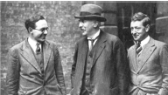
In 1932 Ernest Walton and John Cockcroft verified experimentally Einstein’s equation that relates mass and energy. They accelerated protons through a potential difference of 70 kV before allowing them to collide with lithium metal.
- Draw a labelled diagram of their apparatus.
- Write a nuclear equation for the interaction between a proton and a nucleus of lithium–7.
- The mass of the 1H nuclide is given on page 83 of the Formulae and Tables booklet as1.007825 u.
Convert this mass to kg. (Give your answer to six decimal places.)
- Explain the discrepancy between the value you have calculated and the value given for the mass of the proton on page 47 of the Formulae and Tables booklet.
- Calculate the kinetic energy of the proton as it collided with the metal
- Calculate the mass lost (in kg) during the interaction
- Calculate the energy produced (in J) during the interaction
- Calculate the speed of the alpha particles formed during the interaction.
- A proton may be classified as a hadron. Explain why.
- A proton may also be classified as a baryon. Explain why.

Maths questions involving protons colliding in a particle accelerator

2009 Question 10 (a)
In 1932 Cockcroft and Walton succeeded in splitting lithium nuclei by bombarding them with artificially accelerated protons using a linear accelerator.
Each time a lithium nucleus was split a pair of alpha particles was produced.
- How were the protons accelerated?
- How were the alpha particles detected?
- Write a nuclear equation to represent the splitting of a lithium nucleus by a proton.
- Calculate the energy released in this reaction.
- Most of the accelerated protons did not split a lithium nucleus. Explain why.

Cockcroft and Walton’s apparatus is now displayed at CERN in Switzerland, where very high energy protons are used in the Large Hadron Collider.
In the Large Hadron Collider, two beams of protons are accelerated to high energies in a circular accelerator. The two beams of protons then collide producing new particles. Each proton in the beams has a kinetic energy of 2.0 GeV.
- Explain why new particles are formed.
- What is the maximum net mass of the new particles created per collision?
- What is the advantage of using circular particle accelerators in particle physics?
(mass of alpha particle = 6.6447 × 10^{–27} kg; mass of proton = 1.6726 × 10^{–27} kg;
mass of lithium nucleus = 1.1646 × 10^{–26} kg; speed of light = 2.9979 × 10⁸ m s^{–1};
charge on electron = 1.6022 × 10^{–19} C)

2011 Question 10 (a)
- List three quantities that are conserved in nuclear reactions.
- Write an equation for a nucleus undergoing beta-decay.
- In initial observations of beta-decay, not all three quantities appear to be conserved.
What was the solution to this contradiction?
- List the fundamental forces of nature in increasing order of their strength.
- Which fundamental force of nature is involved in beta-decay?
- In the Large Hadron Collider, two protons with the same energy and travelling in opposite directions collide. Two protons and two charged pi mesons are produced in the collision.
Why are new particles produced in the collision?
- Write an equation to represent the collision.
- Show that the kinetic energy of each incident proton must be at least 140 MeV for the collision to occur.

2008 Question 10 (a)
Baryons and mesons are made up of quarks and experience the four fundamental forces of nature.
- List the four fundamental forces and state the range of each one.
- Name the three positively charged quarks.
- What is the difference in the quark composition of a baryon and a meson?
- What is the quark composition of the proton?
- In a circular accelerator, two protons, each with a kinetic energy of 1 GeV, travelling in opposite directions, collide. After the collision two protons and three pions are emitted.
What is the net charge of the three pions? Justify your answer.
- Calculate the combined kinetic energy of the particles after the collision
- Calculate the maximum number of pions that could have been created during the collision.
(charge on electron = 1.6022 × 10^{–19} C; mass of proton = 1.6726 × 10^{–27} kg;
mass of pion = 2.4842 × 10^{–28} kg; speed of light = 2.9979 × 10⁸ m s^{–1})

2019 Question 12 (d)
The new Swiss 200‐franc note honours proton‐proton collisions in the Large Hadron Collider (LHC) at CERN. There are two families of hadrons.
- Name the two families and distinguish between them.

Two protons, each with a velocity of 0.9c, travelling in opposite directions collide.
A neutral pion ($π^{0}$) and two protons remain after the collision.

- The single pion produced must be neutral. Explain why.
- Calculate the total kinetic energy of the three particles after the collision.

The large hadron collider is a circular accelerator.
- How are the protons maintained in circular motion?

- State the principal advantage of a circular accelerator over a linear accelerator.

2022 Deferred Question 12 [Higher Level]
CERN, based near Geneva, is the European centre for research in particle physics.
The accelerator has been used to find many of the fundamental particles of matter.
In a particle accelerator, two protons are accelerated to half the speed of light before being allowed to collide.
In the collision a single neutral pi meson (π⁰) is formed, as in the equation below. p + p → p + p + π⁰
- Why is it that the pi meson that is formed in the collision must be neutral?
- Assuming that the pi meson produced has a negligible speed, and that both protons have an equal speed of v after the collision, calculate v.

Pair annihilation
2016 Question 12 (d)
{this was the first time that Particle Physics did not come up as a full question. Pick your own adjective to describe how students on the day felt when they realised this.}
- The pair annihilation of an electron and a positron has been investigated for many years at CERN in Switzerland. Two gamma-ray photons are produced during this annihilation.
What is a positron?
- Why are photons always produced in pairs during pair annihilation?
- Write an equation for this annihilation.
- Calculate the frequency of the gamma-radiation produced in this annihilation.
- The pair annihilation of a proton and an anti-proton is now being investigated at CERN.
Compare the energy produced in these two annihilations.
Explain your answer.
{The word produced is a strange one in this context. Produced implies created and we know that energy can’t be created or destroyed so there’s that. Maybe ‘Compare the energy transformed from mass to electromagnetic radiation in each case’ would be more accurate, but that’s probably too much of a mouthful.

2014 Question 11 (a)
Read the following passage and answer the accompanying questions.
Cyclotrons and PET Scanners
Positron emission tomography (PET) scanners are designed to detect the pair of photons generated from the annihilation reaction between a positron and an electron.
A carbon–11 nucleus, which has a half-life of twenty minutes, decays with the emission of a positron. The positron travels only a short distance before colliding with an electron in the surrounding matter. Pair annihilation occurs. The emitted photons travel in opposite directions.

Cyclotrons are located in the same hospital as the PET scanners and are used to manufacture radioactive nuclei. Cyclotrons are circular devices in which charged particles are accelerated in a spiral path within a vacuum. The particles are accelerated by a rapidly alternating voltage and acquire high kinetic energies. They spiral outwards under the influence of the magnetic field until they have sufficent velocity and are deflected into a target producing radioactive nuclei, including carbon–11.
(Adapted from “Essentials of Nuclear Medicine Physics”;
Powsner & Powsner; 1998)
- Electrons are leptons.
List the three fundamental forces that electrons experience in increasing order of strength.
- Write an equation to represent the pair annihilation described in the text.
- Calculate the frequency of each photon produced in this pair annihilation.
- Why do the photons produced in pair annihilation travel in opposite directions?
- Write a nuclear equation to represent the decay of carbon–11.
- What is the value of the decay constant of carbon–11?
- Explain why the carbon–11 nuclei used in the PET scanner must be produced in a cyclotron in, or close to, the same hospital as the scanner.
- Give an expression for the momentum of a particle in the cyclotron in terms of the magnetic flux density of the field, the charge on the particle and the radius of its circular path at any instant.

2012 Question 10 (a)
- What is a positron?
- When a positron and an electron meet two photons are produced.
Write an equation to represent this interaction.
- Why are photons produced in this interaction?
- Explain why two photons are produced.
- Calculate the minimum frequency of the photons produced.
- Explain why the photons produced usually have a greater frequency than your calculated minimum frequency value.
- Why must two protons travel at high speeds so as to collide with each other?
- How are charged particles given high speeds?
- Explain why two positrons cannot annihilate each other in a collision.

2006 Question 10 (a)
During a nuclear interaction an antiproton collides with a proton. Pair annihilation takes place and two gamma ray photons of the same frequency are produced.
- What is a photon?
- Calculate the frequency of a photon produced during the interaction.
- Why are two photons produced?
- Describe the motion of the photons after the interaction.
- How is charge conserved during this interaction?
- After the annihilation, pairs of negative and positive pions are produced. Explain why.
- Pions are mesons that consist of up and down quarks and their antiquarks.
Give the quark composition of (i) a positive pion, (ii) a negative pion.
- List the fundamental forces of nature that pions experience.
- A neutral pion is unstable with a decay constant of 2.5 × 10¹² s^{–1}. What is the half-life of a neutral pion?
(mass of proton= 1.673 × 10^{–27} kg; Planck constant = 6.626 × 10^{–34} J s; speed of light = 2.998 × 10⁸ m s^{–1} )

2018 Question 10 (a)
Momentum, energy and charge are conserved in all nuclear reactions.
In beta‐decay an unstable nucleus emits an electron.
In the early 20th century it was found that momentum and energy did not appear to be conserved during beta‐decay. To solve this apparent problem, Wolfgang Pauli predicted the existence of an unknown particle, about which he said:
I have done a terrible thing. I have postulated a particle that cannot be detected.
- Name the particle which Pauli predicted and explain how it solved the problem.
- Write a nuclear equation for beta‐decay.
- Why did Pauli think that the particle could not be detected?

The conservation laws also apply to pair annihilation.
Pair annihilation can be described using the following equation for an electron and a positron at rest.
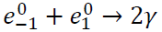

- Why are two gamma‐ray photons produced?
- Explain how charge is conserved in the annihilation.
- Calculate the maximum frequency of each emitted photon.
- Electrons are negatively charged leptons. List the two other negatively charged leptons.
- List the three forces that these leptons can experience, in decreasing order of strength.

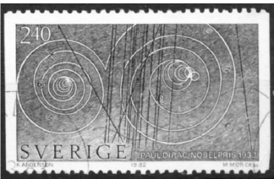
Question 12 Higher Level 2023

(a) Anti‐matter is the most expensive substance on Earth, costing about €65 trillion per gram.
- What is anti‐matter?
- Who made a mathematical prediction of the existence of anti‐matter?
- A positron is an example of anti‐matter.
Write an equation to show the pair production of an electron‐positron pair.
- Explain how (a) charge, (b) momentum are conserved in this interaction.
- List the fundamental forces, in order of increasing strength, that a positron experiences.
- Name the fundamental force that a positron does not experience.

In the Large Hadron Collider researchers are investigating the pair annihilation of a proton anti‐proton pair.
- Calculate the wavelength of the electromagnetic radiation produced when a proton and an anti‐proton annihilate.
- Hadrons can be classified as baryons or mesons. Distinguish between baryons and mesons.
- State the quark composition of (a) a proton, (b) an anti‐proton.
- The Large Hadron Collider is an example of a modern particle accelerator.
Explain how it differs from the particle accelerator used by Cockroft and Walton.

Pair production
2010 Question 10 (a)
- What is anti-matter?
- An anti-matter particle was first discovered during the study of cosmic rays in 1932.
Name the anti-particle and give its symbol.
- What happens when a particle meets its anti-particle?
- What is meant by pair production?
- A photon of frequency 3.6 × 10²⁰ Hz causes pair production.
Calculate the kinetic energy of one of the particles produced, each of which has a rest mass of 9.1×10^{–31} kg.
- A member of a meson family consists of two particles. Each particle is composed of up and down quarks and their anti-particles.
Construct the possible combinations. Deduce the charge of each combination and identify each combination.
- What famous Irish writer first thought up the name ‘quark’?

2003 Question 10 (a)
- Leptons, baryons and mesons belong to the “particle zoo”.
Give (i) an example, (ii) a property, of each of these particles.
- The following reaction represents pair production.
γ → e⁺ + e–
Calculate the minimum frequency of the γ-ray photon required for this reaction to occur.
- What is the effect on the products of the reaction if the frequency of the γ-ray photon exceeds the minimum value?
- The reverse of the above reaction is known as pair annihilation.
Write a reaction that represents pair annihilation.
- Explain how the principle of conservation of charge and the principle of conservation of momentum apply in pair annihilation.
mass of electron = 9.1 × 10^{–31} kg; speed of light, c = 3.0 × 10⁸ m s^{–1} ; Planck constant, h = 6.6 × 10^{–34} J s

2021 Question 13 (a) [Higher Level]
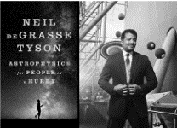
(a) Read the following passage and answer the accompanying questions.
In the beginning, nearly 14 billion years ago, all the space, matter and energy of the universe was contained in a volume less than one trillionth the size of the full stop that ends this sentence. The forces of nature that define the universe were unified. As the universe rapidly expanded within a fraction of a second, in what is known as the Planck era, this unified force split into the four distinct forces that we now understand. At this time, matter in the form of subatomic particles and energy in the form of photons incessantly interplayed. Photons converted into matter‐antimatter pairs which immediately annihilated returning their energy back to photons. The universe was now a seething soup of quarks and leptons. As it continued to expand and cool quarks joined to form new particles called hadrons. At this stage the universe had expanded to a few light years across and one second had elapsed.
In CERN a circular particular accelerator called the Large Hadron Collider is being used to recreate these conditions.
- State the quark composition of the proton.
- List the forces experienced by a proton in decreasing order of strength.
- The Planck constant relates energy and frequency. Its value is 6.6 × 10^{–34} J s.
Express this unit in terms of metres, kilograms and seconds.
- Write a nuclear equation for the pair annihilation of a proton and an antiproton.
- A photon produces a muon anti‐muon pair. Calculate the minimum energy of the photon in electronvolts.
- In the Large Hadron Collider, how are the particles (a) accelerated, (b) maintained in circular motion?
- In 1932 Walton and Cockcroft manufactured one of the first useful particle accelerators.
State two reasons why their experiments using this accelerator were of scientific significance.

Neutrinos
2015 Question 10 (a)
There are about a trillion neutrinos from the Sun passing through your hand every second.
Neutrinos are fundamental particles and are members of the lepton family.
Leptons are not subject to the strong nuclear force.
- What is the principal force that neutrinos experience?
- Electrons are also members of the lepton family. Name two other leptons.
- Name one fundamental particle that is subject to the strong nuclear force.
- Pauli proposed that a neutrino is emitted during beta-decay.
Why did he make this proposal?
- During beta-decay, a neutron decays with the emission of a proton, an electron and a neutrino.
Write a nuclear equation to represent beta-decay.
- Calculate the energy released, in MeV, during beta-decay.
- An electron can be detected in a cloud chamber.
However it is much more difficult to detect a neutrino. Explain why.
- In a cloud chamber an electron travels perpendicular to the direction of a magnetic field of flux density 90 mT and it follows a circular path.
Calculate the radius of the circle when the electron has a speed of 1.45 × 10⁸ m s^{–1}.
- Describe the path of a neutrino in the same magnetic field.

2004 Question 10 (a)
- Beta decay is associated with the weak nuclear force.
List two other fundamental forces of nature and give one property of each force.
- In beta decay, a neutron decays into a proton with the emission of an electron.
Write a nuclear equation for this decay. Calculate the energy released during the decay of a neutron.
- Momentum and energy do not appear to be conserved in beta decay. Explain how the existence of the neutrino, which was first named by Enrico Fermi, resolved this.

During the late 1930s, Fermi continued to work on the nucleus.
His work led to the creation of the first nuclear fission reactor in Chicago during 1942.
The reactor consisted of a ‘pile’ of graphite moderator, uranium fuel with cadmium control rods.

- What is nuclear fission?
- What is the function of the moderator in the reactor?
- How did the cadmium rods control the rate of fission?
mass of neutron = 1.6749 × 10^{–27} kg; mass of proton = 1.6726 × 10^{–27} kg;
mass of electron = 9.1094 × 10^{–31} kg; speed of light = 2.9979 × 10⁸ m s^{–1}

2020 Question 10 [Higher level]
Fermilab is an American particle physics laboratory, named after the Italian physicist Enrico Fermi.
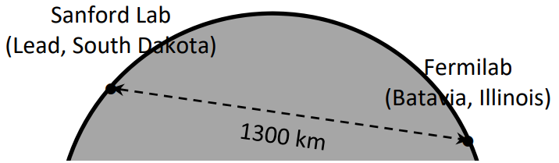
Work on the Deep Underground Neutrino Experiment (DUNE) commenced in Fermilab in 2017, with a planned completion date of 2026. Protons will be accelerated to hit a fixed target.
They will produce pions and kaons, which will then decay and transform into an intense beam of neutrinos.
The neutrinos will travel at 0.99c through the Earth, no tunnel required, to a neutrino detector in South Dakota.

- What are the two fundamental forces that the neutrino experiences?
- Pions and kaons are members of the meson family. What are mesons?
- List the three types of neutrino in order of increasing mass.
- Why is no tunnel required to transport the neutrinos underground to South Dakota?
- Calculate the time taken for the neutrino to travel from Fermilab to South Dakota.

In another experiment in Fermilab two protons, each with a kinetic energy of 29 GeV, collide and new particles are created.
After the collision, the total kinetic energy of the two protons and the new particles is 16 GeV.
- Calculate the total mass of the new particles created.
- Enrico Fermi proposed the existence of the neutrino. He also built the first self‐sustaining nuclear fission reactor.
What is nuclear fission?
- Why was Fermi’s nuclear reactor self‐sustaining?
- Graphite was used in his nuclear reactor. What was the purpose of the graphite?
- Is nuclear fission a spontaneous or a non‐spontaneous process? Explain your answer.

2022 Deferred Question 12 [Higher Level]
Explain what is meant by the following terms:
(i) quark (ii) lepton (iii) meson (iv) baryon.
- State the quark composition of the proton and the neutron.
- Anti‐matter is composed of particles that have the same mass as particles of ordinary matter but have opposite charge. They can be created in particle accelerator laboratories such as CERN.
Name the scientist who predicted the existence of anti‐matter.

PARTICLE PHYSICS EXAM SOLUTIONS 2002 – 2022

2002 Question 10 (a)

- Name the four fundamental forces of nature.
Gravitational, Electromagnetic, Strong nuclear, Weak nuclear

- Which force is responsible for binding the nucleus of an atom?
Strong

- Give two properties of this force.
Short range, act on nucleons, binds nucleus, strongest of all the forces

- Outline this experiment.
Protons are released at the top of the accelerator and get accelerated across a potential difference of 800 kVolt.
These protons collide with a lithium nucleus at the bottom, and as a result two alpha particles are produced.
The alpha particles move off in opposite directions at high speed.
They then collide with a zinc sulphide screen, where they cause a flash and get detected by microscopes.

- Write a nuclear equation to represent this reaction.
$${}_{1}^{1}{H+{}_{3}^{7}{Li→{}_{2}^{4}{He+{}_{2}^{4}{He}}}}$$

- Calculate the energy released in this reaction.
Mass before = [(1.6730 × 10⁻²⁷) + (1.1646 × 10⁻²⁶)]
Mass after = [2(6.6443 × 10⁻²⁷)]

Mass defect = mass before – mass after
Mass defect = 3.0 x 10⁻²⁹ kg

Using E = mc² ⇒ E = (3.0 x 10⁻²⁹)( 3.00 × 10⁸)² ⇒ E = 2.7 × 10⁻¹² J

2003 Question 10 (a)

- Leptons, baryons and mesons belong to the “particle zoo”.
Give (i) an example, (ii) a property, of each of these particles.
LEPTONS; electron, positron, muon , tau, neutrino
Not subject to strong nuclear force
BARYONS; proton, neutron
Subject to all forces, three quarks
MESONS pi(on), kaon
Subject to all forces, mass between electron and proton, quark and antiquark

- Calculate the minimum frequency of the γ-ray photon required for this reaction to occur.
The energy associated with the gamma ray photon (E = hf) needs to be equal to the energy associated with 2 electrons (E = 2mc²)
hf = 2mc²
(6.6 × 10^{–34})(f) = 2(9.1 × 10^{–31})( 3.0 × 10⁸)²
f = 2.5×10²⁰ Hz

- What is the effect on the products of the reaction if the frequency of the γ-ray photon exceeds the minimum value?
The electrons which were created would move off with greater speed.
There may also be more particles produced.

- Write a reaction that represents pair annihilation.
e⁺ + e⁻ → 2γ

- Explain how the principle of conservation of charge and the principle of conservation of momentum apply in pair annihilation.
Charge:
The net charge of the electron and positron is 0, and there is no charge associated with the gamma ray photons.
Momentum:
The electron and positron are moving directly towards each other, so net momentum beforehand = 0, and afterwards the two photons move in opposite directions so net momentum after = 0.

2004 Question 10 (a)

- List two other fundamental forces of nature and give one property of each force.
Strong nuclear force: acts on nucleus/protons + neutrons/hadrons/baryons/mesons, short range
Gravitational force: attractive force, inverse square law/infinite range, all particles
Electromagnetic force: acts on charged particles, inverse square law/infinite range

- Write a nuclear equation for this decay.
$${}_{0}^{1}{n→{}_{1}^{1}p}+{}_{-1}^{0}e$$

- Calculate the energy released during the decay of a neutron.
Mass before = mass of neutron = 1.6749 × 10^{–27} kg
Mass after = mass of proton + mass of electron
= 1.6726 × 10^{–27} + 9.1094 × 10^{–31} = 1.6817 × 10^{–27} kg

Loss in mass (mass defect) = (1.6749 × 10^{–27} kg) – (1.6817 × 10^{–27} kg )
= 1.3891 × 10⁻³⁰ kg

E = mc² = (1.3891 × 10⁻³⁰)(2.9979 × 10⁸)² = 1.25 × 10¹³ J

- Explain how the existence of the neutrino, which was first named by Enrico Fermi, resolved this.
Momentum and energy are conserved when the momentum and energy of the associated neutrino are taken into account.

- What is nuclear fission?
Fission is the splitting of a large nucleus into two smaller nuclei with the release of energy.

- What is the function of the moderator in the reactor?
It slows down the fast neutrons (so that they in turn can be captured by the uranium atoms and cause the uranium nuclei to undergo fission).

- How did the cadmium rods control the rate of fission?
They absorbed the neutrons which would otherwise cause fission.

2005 Question 11 (a)

- What is the structure of an alpha particle?
An alpha particle is identical to a helium nucleus (2 protons and 2 neutrons).

- What conclusion did he form about the structure of the atom?
The atom was mostly empty space with a dense positively-charged core and with negatively-charged electrons in orbit at discrete levels around it.

- High voltages can be used to accelerate alpha particles and protons but not neutrons. Explain why.
Alpha particles and protons are charged, neutrons are not.

- Copy and complete the following nuclear equation for this reaction.
+ → + K.E.

- Give an advantage of circular accelerators over linear accelerators.
Circular accelerators result in progressively increasing levels of energy and occupy much less space than an equivalent linear accelerator.

- Explain why new particles are produced.
The kinetic energy of the two protons gets converted into mass.

- List the six flavours of quark.
Up, down, strange, charm, top and bottom.

- Give the quark composition of the proton.
Up, up, down.

2006 Question 10 (a)

- What is a photon?
A photon is a discrete amount of electromagnetic radiation.

- Calculate the frequency of a photon produced during the interaction.
The equation for pair annihilation is as follows: $p^{+}+p^{- }→2γ$
To calculate the frequency we first need to establish how much mass gets ‘annihilated’ and then calculate how much energy that releases.Mass of particles beforehand = mass of proton + mass of antiproton
= 2(1.673 × 10⁻²⁷) = 3.346 × 10⁻²⁷ kg

The energy released is calculated from E = mc²
E = (3.346 × 10⁻²⁷ )(2.998 × 10⁸)² = 3.0074 × 10⁻¹⁰ J

This is the energy that now becomes associated with two photons.
So energy associated with one photon = 1.5037 × 10⁻¹⁰ J

We then use E = hf ⇒ $f=\frac{E}{h}$ $f=\frac{1.5037 ×{10}^{-10}}{6.626 × {10}^{-34}}$ f = 2.2694 × 10²³ Hz

- Why are two photons produced?
So that momentum is conserved.

- Describe the motion of the photons after the interaction.
They move in opposite directions.

- How is charge conserved during this interaction?
Total charge before = +1-1 = 0
Total charge after = 0 since photons have zero charge

- After the annihilation, pairs of negative and positive pions are produced. Explain why.
The energy of the photons is converted into matter .

- Give the quark composition of (i) a positive pion, (ii) a negative pion.
π⁺ = up and anti-down
π⁻ = down and anti-up

- List the fundamental forces of nature that pions experience.
Electromagnetic, strong, weak , gravitational

- What is the half-life of a neutral pion?
$T_{1/2}=\frac{ln2}{λ}$ $T_{1/2}=\frac{ln2}{2.5 × {10}^{12}}$ T_{1/2} = 2.8 ×10⁻¹³ seconds

2007 Question 10 (a)
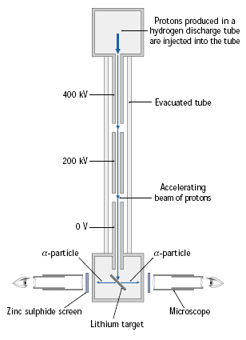
- Draw a labelled diagram to show how Cockcroft and Walton accelerated the protons.
See diagram.

- What is the velocity of a proton when it is accelerated from rest through a potential difference of 700 kV?
$$QV=\frac{1}{2}mv^{2}$$

$v^{2}=\frac{2QV}{m}$ = $\frac{(2)(1.6022×{10}^{-19})(7×{10}^{5})}{1.6727×{10}^{-27})}$ = 1.16 × 10⁷ m s⁻¹

- Write a nuclear equation to represent the disintegration of a lithium nucleus when bombarded with a proton.
${}_{3}^{7}{Li}$+${}_{1}^{1}H→{}_{2}^{4}{He}+{}_{2}^{4}{He+kinetic energy}$
(accept α for He )

- Calculate the energy released in this disintegration.
Mass beforehand (mass of reactants) = 1.1646 × 10⁻²⁶ + 1.6726 × 10⁻²⁷ = 1.33186 × 10⁻²⁶ kg
Mass afterwards (mass of products) = 2(6.6443 × 10⁻²⁷) = 1.32886 × 10⁻²⁶ kg
Loss in mass = 1.33186 × 10⁻²⁶ kg - 1.32886 × 10⁻²⁶ kg = 3.00 × 10⁻²⁹ kg
E = mc² or = (3.00 × 10⁻²⁹)(9 × 10¹⁶) = E = 2.7 × 10⁻¹² J

- Compare the properties of an electron with that of a positron.
Both have equal mass / charges equal / charges opposite in sign

- What happens when an electron meets a positron?
Pair annihilation occurs.

- How did Fermi’s theory of radioactive decay resolve this?
Fermi (and Pauli) realised that another particle must be responsible for the missing momentum, which they called the neutrino.

2008 Question 10 (a)

- List the four fundamental forces and state the range of each one.
Strong (short range), Weak (short range), Gravitational (infinite range), Electromagnetic (infinite range).
We should really be more specific here in relation to the range of the Strong and Weak forces and say that their range is of the order of the diameter of the nucleus of an atom.
- Name the three positively charged quarks.
Up, top, charm.
- What is the difference in the quark composition of a baryon and a meson?
Baryon: three quarks
Meson: one quark and one antiquark
- What is the quark composition of the proton?
Up, up, down
- What is the net charge of the three pions? Justify your answer.
The total charge beforehand was +2 (due to the two protons).
Therefore the total charge afterwards must be +2 (due to conservation of charge).
But there are also 2 protons afterwards, so they account for the +2 by themselves.
So the net charge (or all other particles added together) must therefore be zero.

- Calculate the combined kinetic energy of the particles after the collision.
P⁺ + P⁺ + kinetic energy (of protons) → P⁺ + P⁺ + π + π + π + kinetic energy

So in effect the kinetic energy beforehand went into producing 3 pions, and whatever was left over became the kinetic energy of those pions plus protons.
So to find this kinetic energy we need to subtract the energy required to make the 3 pions away from the original kinetic energy.

Kinetic energy beforehand = 2 GeV = (2 × 10⁹) (1.6 × 10⁻¹⁹) = 3.2 × 10⁻¹⁰ Joules

Energy required to produce 3 pions: E = 3mc² = 3(2.4842 × 10^{–28})( 2.9979 × 10⁸)²
= 6.6981 × 10^{–11} Joules

Kinetic energy after collision = (3.2 × 10⁻¹⁰) - (6.6981 × 10^{–11}) = 2.53 × 10^{–10} J

- Calculate the maximum number of pions that could have been created during the collision.
Kinetic energy beforehand = 3.2 × 10⁻¹⁰ Joules

Energy required to produce 1 pion = mc² = (2.4842 × 10^{–28})( 2.9979 × 10⁸)² = 2.2327 × 10^{–11} Joules

Number of pions = $\frac{3.2 × {10}^{-10}}{2.2327×{10}^{-11}}$ = 14.35

So the maximum number that could have been created is 14 pions.

2009 Question 10 (a)

- How were the protons accelerated?
They were accelerated by the very large potential difference which existed between the top and the bottom

- How were the alpha particles detected?
They collide with a zinc sulphide screen, where they cause a flash and get detected by microscopes.

- Write a nuclear equation to represent the splitting of a lithium nucleus by a proton.
+ → + K.E.

- Calculate the energy released in this reaction.
Loss in mass:
Mass before = mass of proton + mass of lithium nucleus
= (1.6726 × 10^{–27}) + (1.1646 × 10^{–26})
= 1.33186 × 10⁻²⁶ kg

Mass after = mass of two alpha particles = 2 × (6.6447 × 10^{–27}) = 1.32894 × 10⁻²⁶ kg

Loss in mass = (1.33186 × 10⁻²⁶) – (1.32894 × 10⁻²⁶) = 2.92 × 10⁻²⁹ kg

E = mc² = (2.92 × 10⁻²⁹) (2.9979 × 10⁸)² = 2.6 × 10⁻¹² J

- Most of the accelerated protons did not split a lithium nucleus. Explain why.
The atom is mostly empty space so the protons passed straight through.

- Explain why new particles are formed.
When the protons collide into each other they lose their kinetic energy and it is this energy which gets converted into mass to form the new particles.

- What is the maximum net mass of the new particles created per collision?
The maximum that can be created would occur if all of the kinetic energy was converted into mass.
Total energy = 4 GeV
G = Giga = × 10⁹
1 eV = 1.6 × 10⁻¹⁹ Joules
4 GeV = (4 × 10⁹) (1.6 × 10⁻¹⁹) = 6.4× 10⁻¹⁰ Joules

E = mc² ⇒ $m=\frac{E}{c^{2}}= \frac{6.4 ×{10}^{-10}}{{(2.9979 × 10}^{8)2}}$ ⇒ m = 7.121 × 10⁻²⁷ kg

- What is the advantage of using circular particle accelerators in particle physics?
You can achieve greater (particle) speeds with a circular accelerator / They take up less space

2010 Question 10 (a)

- What is anti-matter?
Antimatter is material/matter/particles that has the same mass as another particle but opposite charge.

- Name the anti-particle and give its symbol.
positron / anti-electron

- What happens when a particle meets its anti-particle?
Pair annihilation occurs and the mass gets converted to energy.

- What is meant by pair production?
Pair production involves the production of a particle and its antiparticle from a gamma ray photon.

- Calculate the kinetic energy of one of the particles produced, each of which has a rest mass of 9.1 × 10^{–31} kg.
Energy of incident photon = energy required to create 2 particles + kinetic energy of particles
Energy of incident photon = hf E = (6.6 × 10⁻³⁴)( 3.6 × 10²⁰) = 2.376 × 10⁻¹³ J

Energy required to produce the two particles = 2[mc²]
E = 2(9.1 × 10⁻³¹)(3.0 × 10⁸)² = 1.638 × 10⁻¹³ J

Energy of incident photon = energy required to create 2 particles + kinetic energy of particles
2.376 × 10⁻¹³ J = 1.638 × 10⁻¹³ J + kinetic energy

Extra energy available for kinetic energy = (2.376 × 10⁻¹³) – (1.638 × 10⁻¹³) = 7.38 × 10⁻¹⁴

Kinetic energy per particle is half of this = 3.69 × 10⁻¹⁴ Joules

- Construct the possible combinations.
Deduce the charge of each combination and identify each combination.

composition |  | charge | name
u | $$\overline{u}$$ | 0 | Pi-neutrino
u | $$\overline{d}$$ | +1 | Pi-plus
d | $$\overline{u}$$ | -1 | Pi-minus
d | $$\overline{d}$$ | 0 | Pi-neutrino

- What famous Irish writer first thought up the name ‘quark’?
James Joyce

2011 Question 10 (a)

- List three quantities that are conserved in nuclear reactions.
Momentum, charge, mass-energy
- Write an equation for a nucleus undergoing beta-decay.
$${}_{27}^{60}{Co}→{}_{-1}^{0}e+{}_{28}^{60}{Ni}$$

- In initial observations of beta-decay, not all three quantities appear to be conserved.
What was the solution to this contradiction?
The discovery of the neutrino which accounted for the missing momentum.
- List the fundamental forces of nature in increasing order of their strength.
gravitational < weak (nuclear) < electromagnetic < (strong) nuclear
- Which fundamental force of nature is involved in beta-decay?
The weak force.
- Why are new particles produced in the collision?
The kinetic energy of the protons is converted into mass.
- Write an equation to represent the collision.
p + p + KE $→$ p + p + $π$⁺ + π⁻ + KE
- Show that the kinetic energy of each incident proton must be at least 140 MeV for the collision to occur.
We need to find out how much energy is required to produce {just} two pions {with no kinetic energy}.
So we will be using E = 2m_{π}c² where m_{π} represents the mass of one pion.
But we don’t have a value for the mass of a pion, just it’s mass relative to the mass of an electron.

Mass of π⁺ = (273)(m_{e)} = 273(9.109×10⁻³¹ kg) = 2.4869×10⁻²⁸ kg

E = 2m_{π}c²
E = 2(2.4869×10⁻²⁸)(3×10⁸)² = 44.76 ×10⁻¹² J

We now need to convert this to eV. 1 eV = 1.602 ×10⁻¹⁹ Joules, so we need to divide the our number in Joules by 1.602 ×10⁻¹⁹ to get the equivalent value in eV.
$$E=\frac{44.76×{10}^{-12}}{1.602×{10}^{-19}}= 279.94 ×{10}^{6} eV ≈ 280 MeV$$

This is the total kinetic energy associated with two protons, so the kinetic energy of each proton must be 140 MeV.

2012 Question 10 (a)
- What is a positron?
A positron is an electron with a positive charge.
- When a positron and an electron meet two photons are produced.
Write an equation to represent this interaction.
$${}_{-1}^{0}e+ {}_{+1}^{0}{e → γ+ γ}$$

OR $e^{+}+e^{- }→2γ$

- Why are photons produced in this interaction?
The mass of the electron and positron gets converted into energy
- Explain why two photons are produced.
To conserve momentum.
- Calculate the minimum frequency of the photons produced.
Two electrons ‘disappear’ and two photons are created, so we can assume that the each electron ‘is converted to’ a photon.
Mass of electron = 9.1093826 × 10⁻³¹ kg
The energy associated with an electron is given by E = mc²
E = (9.1093826 × 10⁻³¹)(3 × 10⁸)²
E = 8.198444 × 10⁻¹⁴ J

This now becomes the energy of the photon: E = hf
$f= \frac{E}{h}= \frac{{8.198444 × 10}^{-14}}{{6.6260692 × 10 }^{-34}}$ f = 1.237 × 10²⁰ Hz

- Explain why the photons produced usually have a greater frequency than your calculated minimum frequency value.
In addition to rest mass the colliding particles have kinetic energy.
- Why must two positrons travel at high speeds so as to collide with each other?
To overcome the force of repulsion
- How are charged particles given high speeds?
Particle accelerators / linear accelerator / cyclotron /synchrotron/magnetic fields/electric fields
- Explain why two positrons cannot annihilate each other in a collision.
This would involve a conflict with conservation of charge.

2013 Question 10 (a)

- How did Cockroft and Walton accelerate the protons?
High voltage / large electric field
- How did they detect the alpha-particles?
When the alpha particles hit a zinc sulfide screen it resulted in flashes of light
- Write the nuclear equation for the reaction that occurred.
+ → + K.E.
- Indicate the historical significance of their observation.
It was the 1st experimental verification of E = mc² / first artificial splitting of the nucleus (atom) /
first transmutation using artificially accelerated particles
- Calculate the speed of a proton that has a kinetic energy of 700 keV.
The kinetic energy is 700 keV, so we need to convert this to Joules.
1eV =1.6 x 10^{–19} Joules
700 keV = (700 x 10³)(1.6 x 10^{–19}) Joules

Kinetic energy = 1.12 × 10^{–13} J

Now we use E_{kinetic} = ½mv²
1.12 × 10^{–13} = ½ mv²
$$v^{2}{=(2)(\frac{{1.12 × 10}^{–13}}{m} )}^{}$$

Mass of proton = 1.6730 × 10⁻²⁷ kg

$$v^{2}{=(2)(\frac{{1.12 × 10}^{–13}}{{1.6730 × 10}^{–27 }} )}^{}$$
v = 1.16 × 10⁷ m s⁻¹

- Why is the tube evacuated?
So that particles do not collide with gas particles

- What is the purpose of accelerating the particles to high velocities?
To overcome repulsive forces // to create new matter

- What is the purpose of the magnets?
To contain the particles (in a circular path)

- Give an advantage of a circular accelerator over a linear accelerator.
Takes up less space // particles can achieve greater energy / speed

Can an accelerator of this design be used to accelerate neutrons? Explain your answer.
No
Neutrons have no charge and are therefore not affected by electric / magnetic fields

2014 Question 11 (a)

- List the three fundamental forces that electrons experience in increasing order of strength.
gravitational, weak (nuclear) and electromagnetic

- Write an equation to represent the pair annihilation described in the text.
e− + e+ → 2hf
OR$${}_{-1}^{0}{e+ {}_{+1}^{0}{e →2γ}}$$
- Calculate the frequency of each photon produced in this pair annihilation.
Mass of electron = 9.1093826 × 10⁻³¹ kg
Energy ‘released’ when one electron is annihilated = mc²

(2)(9.1093826 × 10⁻³¹)(3 × 10⁸)² = (2)(6.6260692 × 10⁻³⁴)(f)

- Why do the photons produced in pair annihilation travel in opposite directions?
momentum is conserved

- A carbon–11 nucleus, which has a half-life of twenty minutes, decays with the emission of a positron. Write a nuclear equation to represent the decay of carbon–11.
$$c_{6}^{11}→ B_{5}^{11}+ e_{1}^{0}$$

- What is the value of the decay constant of carbon–11?
T_{1/2} = $\frac{ln2}{λ}$ λ = $\frac{ln2}{T_{1/2}}$ Half-life is 20 minutes = (20)(60) = 1200 seconds

λ = $\frac{0.693}{1200}$ λ = 0.000578 s⁻¹

- Explain why . . .
Because of their short half-life - too many would have decayed before they could be used.

- Give an expression . . .
The word ‘radius’ is the clue that tells us we’re talking about a centripetal force, the term ‘magnetic flux density’ is the clue that tells us that we’re talking about a magnetic force.
Equate the expression for both and rearrange so that we get mv (momentum) on one side:
Centripetal force = magnetic force$$\frac{mv^{2}}{r}=Bqv$$
Cancel one v on both sides and multiply both sides by r to get rid of the r on the left hand side.
⇒ mv = Bqr

2015 Question 10 (a)
- What is the principal force that neutrinos experience? Weak (nuclear force)

- Name two other leptons. Muon, tau, positron

- Name one fundamental particle that is subject to the strong nuclear force. Quark

- Why did he make this proposal? Momentum/energy not conserved

- Write a nuclear equation to represent beta-decay.
$$n_{0}^{1}→H_{1}^{1} {+e}_{-1}^{0}+v$$

- Calculate the energy released, in MeV, during beta-decay.
Page 46, 47 and 48 of log tables to get values for the mass of the particles.

Mass of neutron: 1.674 927 28 × 10⁻²⁷ kg Mass of proton: 1.672 621 71 × 10⁻²⁷ kg
Mass of electron: 9.109 3826 × 10⁻³¹ kg
Mass of neutrino: see page 48 of log tables; the mass of the neutrino is given relative to the mass of an electron. Mass of neutrino = (4.305 × 10⁻⁶)(9.109 3826 × 10⁻³¹) = 3.921589209 × 10⁻³⁶ kg

Mass before = mass of neutron= 1.674 927 28 × 10^{–27} kg

Mass after = mass of proton + mass of electron + mass of neutrino
= 1.672 621 71 × 10⁻²⁷ kg + 9.109 3826 × 10⁻³¹ kg + 3.921589209 × 10⁻³⁶ kg

Total mass after = 1.673532652 × 10⁻²⁷ kg

Loss in mass = total mass beforehand – total mass afterwards
= (1.674 927 28 × 10^{–27} kg) – (1.673532652 × 10⁻²⁷ kg)

Loss in mass = 1.395 × 10^{–30} kg
To calculate the energy associated with this mass we need to use E = mc²
E = (1.395 × 10^{–30})(2.997 924 58)² E = 1.25 × 10⁻¹³ J

Now we need to convert from Joules to eV
1 eV = 1.602 176 53 × 10⁻¹⁹ J {page 46 of log tables}

So we need to divide 1.25 × 10⁻¹³ by 1.602 176 53 × 10⁻¹⁹ E = 780188 eV
Now divide by 1×10⁶ to convert to MeV {M = mega = 10⁶} E = 0.78 MeV

- However it is much more difficult to detect a neutrino. Explain why.
The neutrino has no charge and only a very small mass.

- Calculate the radius of the circle when the electron has a speed of 1.45 × 10⁸ m s^{–1}.

The force experience by a charged particle in a magnetic field is given by the equation F = Bqv.
The force experience by a particle moving in a circle is given by the equation F = mv²/r
Equating both expressions:
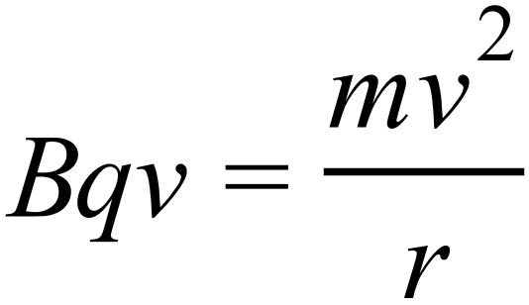 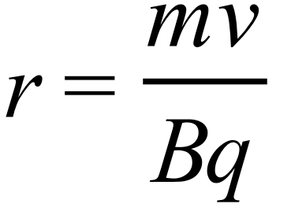 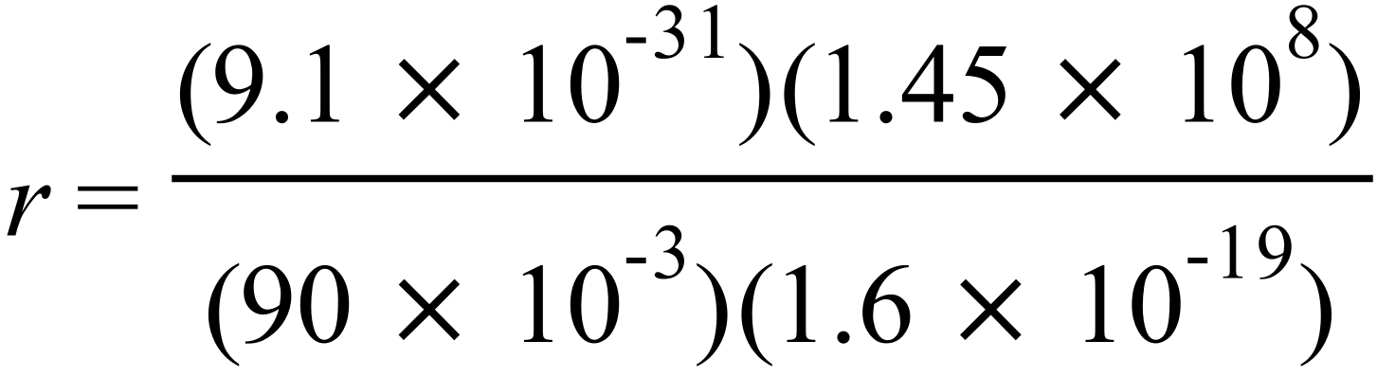 r = 9.16 × 10^{–3} m

Describe the path of a neutrino in the same magnetic field.
No deviation
2016 Question 12 (d)

- What is a positron?
Positively charged electron // anti-electron

- Why are photons always produced in pairs during pair annihilation?
To conserve momentum

- Write an equation for this annihilation.
$${}_{-1}^{0}{e+ {}_{+1}^{0}{e →2γ}}$$

- Calculate the frequency of the gamma-radiation produced in this annihilation.
Mass of electron = 9.1093826 × 10⁻³¹ kg
Energy ‘released’ when one electron is annihilated = mc²
We only need to look at one electron because two electrons are annihilated to produce two photons, so it’s as if one electron is responsible for producing one photon.
E = (9.1093826 × 10⁻³¹)(3 × 10⁸)²
E = 8.198444 × 10⁻¹⁴ J

This energy now goes on to create a photon
Energy associated with a photon = hf
$f= \frac{E}{h}= \frac{{8.198444 × 10}^{-14}}{{6.6260692 × 10 }^{-34}}$

f = 1.237 × 10²⁰ Hz

- Compare the energy produced in these two annihilations.
Explain your answer.
Energy from proton annihilation is greater because a proton’s mass is greater

2017 Question 12 (d)

- Explain how the protons were produced.
ionisation / discharge tube
- Explain how the protons were accelerated.
high voltage
- Explain how the alpha-particles were detected.
flashes / zinc sulphide / screen

- Write the nuclear equation for this reaction.
+ → + K.E.
For this reaction, calculate the loss in mass and hence the energy released (in MeV).
Mass beforehand (mass of reactants) = 1.1646 × 10⁻²⁶ + 1.6726 × 10⁻²⁷ = 1.33186 × 10⁻²⁶ kg
Mass afterwards (mass of products) = 2(6.6443 × 10⁻²⁷) = 1.32886 × 10⁻²⁶ kg
Loss in mass = 1.33186 × 10⁻²⁶ kg - 1.32886 × 10⁻²⁶ kg = 3.00 × 10⁻²⁹ kg
E = mc² or = (3.00 × 10⁻²⁹)(9 × 10¹⁶) = 2.7 × 10⁻¹² J

Converting to eV: 1.6 × 10⁻¹⁹ J = 1 eV

2.7 × 10⁻¹² J = $\frac{{2.7 × 10}^{-12}}{{1.6 × 10}^{-19}}$ eV = 17.35 × 10⁶ eV = 17.35 MeV
- Explain the historical significance of this experiment.
Verified 𝑬=𝒎𝒄^{𝟐}/ first transmutation by an artificially accelerated particle / important step in development of the particle accelerator / Nobel prize

2018 Question 10 (a)

- Name the particle which Pauli predicted and explain how it solved the problem.
The neutrino; it had the missing energy and momentum
- Write a nuclear equation for beta‐decay.
$$n_{0}^{1}→H_{1}^{1} {+e}_{-1}^{0}+v$$

- Why did Pauli think that the particle could not be detected?
It had no charge and very little mass.

- Why are two gamma‐ray photons produced?
To conserve momentum

- Explain how charge is conserved in the annihilation.
Net charge beforehand = 0 (since the particle and antiparticle have equal and opposite charges)
Photons have no charge so charge afterwards = 0.

- Calculate the maximum frequency of each emitted photon.
Mass of electron = 9.1093826 × 10⁻³¹ kg
Energy ‘released’ when one electron is annihilated = mc²
We only need to look at one electron because two electrons are annihilated to produce two photons, so it’s as if one electron is responsible for producing one photon.
E = (9.1093826 × 10⁻³¹)(3 × 10⁸)²
E = 8.198444 × 10⁻¹⁴ J

This energy now goes on to create a photon
Energy associated with a photon = hf
$f= \frac{E}{h}= \frac{{8.198444 × 10}^{-14}}{{6.6260692 × 10 }^{-24}}$

f = 1.24 × 10²⁰ Hz
- Electrons are negatively charged leptons. List the two other negatively charged leptons.
muon, tau

- List the three forces that these leptons can experience, in decreasing order of strength.
electromagnetic, weak, gravitational

2019 Question 12 (d)

- Name the two families and distinguish between them.
baryon and meson
baryon has three quarks and meson has a quark and an antiquark

- The single pion produced must be neutral. Explain why.
For charge to be conserved.

- Calculate the total kinetic energy of the three particles after the collision.

Total kinetic energy of the 3 particles after = (kinetic energy beforehand) – (energy required to produce the pion)

Step 1: Calculate the kinetic energy beforehand
$${Kinetic energy}_{before}=\frac{1}{2}{mv}^{2}$$
Mass of proton = 1.6726×10⁻²⁷ kg {mass of proton available from page 47 of F&T booklet}

$${Kinetic energy}_{before}=\frac{1}{2}{{(1.6726×10}^{-27})((0.9)(2.9979×{10}^{8})}^{2}$$
${Kinetic energy}_{before}={1.2176×10}^{-10}$ J

Step 2: Calculate the energy required to produce the pion.
Energy to produce the pion: Use E = mc², where m represents the mass of the pion in kg.

Mass of π⁰ = (264)(mass of one electron) {relative mass of π⁰ available from page 48 of F&T booklet}
Mass of π⁰ = (264)(9.1094 × 10⁻³¹ kg) {mass of electron available from page 47 of F&T booklet}
Mass of π⁰ = 2.4048816×10⁻²⁸ kg
Energy to produce the pion = mc² = (2.4048816×10⁻²⁸)(2.9979 ×10⁸)² = 2.1614×10⁻¹¹ J

Energy of the 3 particles after = (kinetic energy beforehand) – (energy required to produce the pion)
Energy of the 3 particles after =$({1.2176×10}^{-10}$) – (2.4048816×10⁻²⁸)(2.9979 ×10⁸)²
Energy of the 3 particles after =$({1.2176×10}^{-10}$) – 2.1614×10⁻¹¹

Energy of the 3 particles after = 1.00 ×10⁻¹⁰ J

- How are the protons maintained in circular motion?
Using magnetic fields

- State the principal advantage of a circular accelerator over a linear accelerator.
“Greater energy can be created”
The line above is taken straight from the official Marking Scheme. Which isn’t overly reassuring when one considers that the answer to the first part of Question 12 (a) is that energy cannot be created. I suppose it just highlights how difficult it is to be precise with the phrases we used. We all ‘know’ what we are trying to say when we use phrases in a vague way like this and usually that’s good enough. The other thing to consider is that the Marking Scheme isn’t saying that they necessarily approve of this answer; just that they were prepared to award it full marks in this instance.
A better answer would be along the following lines: “So that a greater amount of kinetic energy can be transferred to mass energy of the accelerating particles”.

2020 Question 10

- What are the two fundamental forces that the neutrino experiences?
Weak, gravitational
- Pions and kaons are members of the meson family. What are mesons?
Quark and anti‐quark pair
- List the three types of neutrino in order of increasing mass.
Electron neutrino, muon neutrino, tau neutrino.
- Why is no tunnel required to transport the neutrinos underground to South Dakota?
Small mass / no charge / little interaction with matter because the planet is almost completely empty space.
- Calculate the time taken for the neutrino to travel from Fermilab to South Dakota.
$velocity=\frac{displacement}{time}$ $time=\frac{displacement}{velocity}$ $time=\frac{1300000}{(0.99)({3×10}^{8})}$ = 0.0044 secs

In another experiment in Fermilab two protons, each with a kinetic energy of 29 GeV, collide and new particles are created.
After the collision, the total kinetic energy of the two protons and the new particles is 16 GeV.
- Calculate the total mass of the new particles created.
Before the collision the total kinetic energy was 58 GeV. Afterwards it was 16 GeV.
So 42 GeV has been converted into mass energy.
How much mass? We need to use E = mc² to find out.
But before we do that we first need to convert the 42 GeV into joules.
42 GeV = (42×10⁹)(1.6×10⁻¹⁹) = 6.72 × 10⁻⁹ joules.
E = mc² $m=\frac{E}{c^{2}}=\frac{{6.72 × 10}^{-9}}{({{3 × 10}^{8)}}^{2}}$ = 7.48×10⁻²⁶ kg.

- What is nuclear fission?
Splitting of a large nucleus into smaller nuclei with the emission of energy and neutrons.
[−1 for “atom” instead of nucleus]
[−1 for omission of nuclear size]

- Why was Fermi’s nuclear reactor self‐sustaining?
Chain reaction / on average every fission caused another fission

- Graphite was used in his nuclear reactor. What was the purpose of the graphite?
To slow down fast neutrons / to increase the rate of fission / to act as a moderator

- Is nuclear fission a spontaneous or a non‐spontaneous process? Explain your answer.
Non‐spontaneous because a neutron is required to initiate the process.

2021 Question 13 (a)

- State the quark composition of the proton.
up, up, down
- List the forces experienced by a proton in decreasing order of strength.
strong, electromagnetic, weak, gravitational
- Express this unit in terms of metres, kilograms and seconds.
kg m² s⁻¹
- Write a nuclear equation for the pair annihilation of a proton and an antiproton.
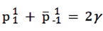
- A photon produces a muon anti‐muon pair. Calculate the minimum energy of the photon in electronvolts.
E = mc²
m = 2m_{μ}
m = 2 × 206.9 × 9.109 × 10^{–31} = 3.769 × 10^{–28} kg
E = 3.388 × 10^{–11} J
E = 2.115 × 10⁸ eV
- In the Large Hadron Collider, how are the particles (a) accelerated, (b) maintained in circular motion?
(a) voltage / electric field / magnetic field
(b) magnetic field
- State two reasons why their experiments using this accelerator were of scientific significance.
first experimental verification of E = mc²
first transmutation using artificially accelerated particles

2022 Question 12
- Draw a labelled diagram of their apparatus
- hydrogen discharge tube
- linear accelerator with voltage applied correctly
- target [at 45°]
- screen/scintillations/microscope

- Write a nuclear equation for the interaction between a proton and a nucleus of lithium–7.
+ → + K.E.

- Convert 1.007825 u to kg. (Give your answer to six decimal places.)
u = 1.6605402×10^{–27} kg.
(1.007825)(1.6605402×10^{–27}) = 1.673534×10^{–27} kg
- Explain the discrepancy . . .
This one is nuts. Page 83 lists the nuclides. These are atoms which are listed by their mass number (A) and the atomic number (Z) and because they are atoms they also include the mass of the electrons.
So a ‘1H nuclide’ is a hydrogen atom which has a mass number of 1, so 1 proton and no neutron – but because it’s an atom it also has one electron! There is nothing on the syllabus (that I am aware of) that suggested this needed to be known. The other source of confusion is the word ‘nuclide’ sounds similar to ‘nucleus’ and could lull some students into confusing one with the other. At least that’s what happened to me .

- Calculate the kinetic energy of the proton as it collided with the metal
kinetic energy of proton at the end = potential energy of the proton at the start
= QV
= (1.60217653×10^{–19})(70000)
= 1.12152357×10^{–14} J
- Calculate the mass lost (in kg) during the interaction
Mass lost = [total mass at the beginning] – [total mass at the end]
= [mass of proton + lithium] – [mass of 2 helium nuclei]
= [7.016005 + 1.007825] – [2(4.002603)]
= 0.018624 u
(0.018624)(1.6605402×10^{–27}) = 3.09259007×10^{–29} kg
- Calculate the energy produced (in J) during the interaction
E = mc²
(3.09259007×10^{–29})(2.99792458 × 10⁸)² = 2.77948134 × 10^{–12} J

- Calculate the speed of the alpha particles formed during the interaction.
The energy ‘produced’ (2.77948134 × 10^{–12} J) takes the form of kinetic energy of the alpha particles moving off afterwards
kinetic energy = ½mv²
2.77948134 × 10^{–12} J = ½(mass of 2 alpha particles) v²
2.77948134 × 10^{–12} J = ½(2)(6.6446565×10^{–27})v²
v = 2.05 × 10⁷ m s^{–1}

- A proton may be classified as a hadron. Explain why.
it experiences the strong force / it is composed of quarks.

- A proton may also be classified as a baryon. Explain why.
baryons are composed of three quarks.

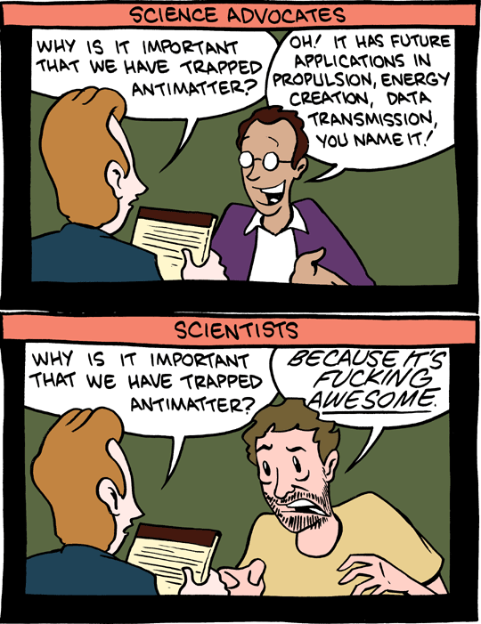

http://smbc-comics.com/index.php?db=comics&id=2088#comic
Not a bad note on which to end your Leaving Cert Physics course – I do hope you enjoyed the ride.
Noel Cunningham

Cockroft and Walton experiment as published in Nature: Disintegration of Lithium by Swift Protons The brightness of the scintillations and the density of the tracks observed in the expansion chamber suggest that the particles are normal a-particles. If this point of view turns out to be correct, it seems not unlikely that the lithium isotope of mass 7 occasionally captures a proton and the resulting nucleus of mass 8 breaks into two a-particles, each of mass four and each with an energy of about eight million electron volts. The evolution of energy on this view is about sixteen million electron volts per disintegration, agreeing approximately with that to be expected from the decrease of atomic mass involved in such a disintegration. J. D. COCKCROFT. E. T. S. WALTON. Published in Nature, April 30, 1932.
It wasn’t the first time a nucleus had been split. Rutherford (who else) accomplished this in 1918 when he bombarded nitrogen with alpha particles from radioactive material. As we now know (don’t we?) it is not possible to predict when an alpha particle will be emitted, so C & W’s experiment was more controlled. Hence the term artificial.
You can see why even Einstein was not optimistic that an experiment of this sort was ever likely to succeed. He stated that “it would be like a blind man trying to shoot ducks, firing into the air in a country where there were very few ducks”.
If you try to accelerate a proton, at first its velocity increases, but as its velocity increases so does its mass (from special relativity), and as a result it gets harder to accelerate it. At a speed of 99.997 the speed of light the mass of the proton is 430 times its ‘rest mass’ (well the energy gained by the proton has to manifest itself somehow and it can’t just keep gaining speed because nothing can go faster than the speed or light. This is also why running particle accelerators is usually done at night; the amount of electricity would actually be enough to power a small town.
Why this term? Because back when scientists were discovering them, zoos weren’t organised like they are now. In fact they weren’t organised at all. Instead of having all animals who would normally live in the African plains together in one section of the zoo, each animal was housed in the next available room. So as a visitor you never knew what you were going to see next as you walked around. A bit like these scientists analysing data from their colliders. “Figuring out what happened in a collider is like trying to figure out what your dog ate at the park yesterday. You can find out, but you have to sort through a lot of sh*t to do it.” MIT physicist Jesse Thaler
Why is there no more antimatter? At the birth of the universe equal amounts of matter and antimatter should have been produced in the Big Bang but somehow the antimatter has all but disappeared (or most likely was annihilated) leaving us in today’s world of matter. Why this is the case nobody knows. By the way, did you know that a typical banana produces antimatter on average every 75 minutes? The source is potassium-40.
At 24, Dirac’s brother committed suicide. Dirac’s oldest child Felix committed suicide when he was 23. His Swiss father insisted that he (the father) should be addressed only in French. Dirac managed to learn it so he was allowed to dine with him but his English mother and his siblings (who failed the test) ate in the kitchen. His prediction about the existence of antimatter was highly controversial until the discovery of the positron in 1932.
Beta-positive decay is what drives PET scanners. (Positron Emission Tomography). You give someone a dose of a chemical (usually Fluorine-18 - an example of a radioisotope) containing suitable short half-life beta+ emitter (emits positrons) and you can track very accurately where that chemical goes in the body, because the positron interacts with a nearby electron to give two very collimated gamma rays which you can detect. Tomography = imaging by sections. Or maybe it’s just a scanner for household pets like dogs and gerbils. But not cats – cos they go in the CAT scanner. Obvs.
If momentum is defined as being the product of mass and velocity and if photons don’t have mass, then surely the momentum is zero? That would be correct if our definition of momentum was correct – but it’s not. We defined momentum only in terms of objects with mass because that things nice and simple, but now what we are looking at pair production we have to acknowledge that electromagnetic radiation has momentum also. For what it’s worth, the 'push' that photons exert on a solar sail is due to their momentum which can be quantified as E/c where E = energy of the photon (hf) and c is the speed of light. Still confusing? Yea I thought so, but do I not at least get some points for acknowledging the source of the confusion?
The disappearance of a photon followed by the appearance of an electron and positron (without any neutron) cannot conserve both total energy and momentum. To ensure that momentum as well as energy is conserved, you need something nearby to participate and absorb the recoil. Most diagrams of pair production show the photon heading directly towards the nucleus; I used to think there had to be collision between the two but now I know better, there just needs to be a nucleus somewhere nearby. This stuff is just mad – you couldn’t make it up!
Other years where this question came up: 2021 Question 13 (a), 2018 Question 10 (a), 2016 Question 12 (d), 2014 Question 11 (a), 2006 Question 10 (a) Note that the question is practically the same each year so it’s definitely worth taking the time to get this right, although in 2006 involved a proton and antiproton instead of an electron and positron.
Fermi’s paper was rejected by the prestigious journal Nature in 1934 because “it contained speculations too remote from reality to be of interest to the reader”. Pauli can’t have been too surprised when he heard this. He himself admitted, “I have done a terrible thing – I have predicted the existence of a particle which cannot be detected.”
So what’s different about the Up, Top and Charmed particles if they all have the same charge? Answer: Mass. The Up has the smallest mass and the Charmed the greatest (which is why it took the longest time to detect). Same goes for Down, Strange and Bottom.
Gell-Mann once wrote that physics at high school was “the dullest course I had ever taken”, and he only applied to study physics at university “to please my father”. Which just goes to show - there’s hope for you yet.
No seriously. I know you think I’m joking but I’m not; you really do need to know this. You still don’t believe me, do you?
The convention is to put a horizontal bar over the letter so signify that it is an anti-particle.
Because mesons are composed of matter and antimatter they don’t tend to survive too long; a typical half-life is 9 × 10⁻¹⁷ seconds before annihilation occurs.
We mentioned something called ‘binding energy’ in the last chapter. It turns out that only about 1% of the mass of a proton is due to the mass of its constituent quarks. The rest is due to the binding energy associated with the quarks. You couldn’t make this stuff up.
How can this be? Surely there are dozens of different forces ... • the push of a compressed spring • the attraction between a magnet and an iron nail • the pull of gravity accelerating a falling apple • the pull of your muscles as you flex your arm • the downward push that you exert on the floor by standing on it • Sellotape sticking to a piece of paper • dry hair flying out towards your hairbrush • air exerting pressure as a result of its molecules being in motion • particles in a liquid or solid being prevented from moving as freely as particles in a gas • two snooker balls colliding and rebounding from each other. All of these can be explained in terms of just two of the four fundamental forces. Which two?
Yes I know it’s really bad. Go make your own. This is as good a spot as any to draw you attention to one more very uncomfortable fact that nobody mentions. There are any number of universal constants in physics. And if their value was just a tiny bit bigger or smaller our universe would never have come into existence, or if it did it wouldn’t have lasted very long. So why did we get so lucky? Nobody knows. As Gottfried Wilhelm Leibniz so aptly put it; “Why is there something rather than nothing?” Google ‘anthropic principle’ for more on this.
The name lepton derives from Greek word leptos meaning “light, not heavy”.
Does not science tell us that its highest striving is after the ascertainment of a unity which shall bind the smallest things with the greatest? George Eliot wrote The Mill on the Floss in 1860, 100 years before physicists themselves realised that this is what they were trying to do. Here’s something not many people realise. For the last few decades of his life physicists had little interest in reading any of Einstein’s work or even inviting him to their seminars. Why did one or out greatest ever scientists fall so out of favour? The answer lies in attempts to unify the four fundamental forces outlined above. Einstein was obsessed with this and every few years was convinced that he had the solution only for someone to come along and point out his (Einstein’s) mistake. Eventually he ended up like the boy who cried wolf and, though he was still feted by celebrities and politicians alike, his scientific output no longer gained the respect it once did. His other great mistake was not accepting Quantum Physics. He always considered it an incomplete theory and couldn’t accept the probabilistic nature of it (there is no way to determine when a given radioactive nucleus will undergo decay). He was aware of this himself and noted at one point that "I must seem like an ostrich who forever buries its head in the relativistic sand in order not to face the evil quanta."
Superstring theory is an attempt to explain how all four fundamental forces of nature are inter-connected by modelling them as vibrations of tiny supersymmetric strings (like I know what that even means). The problem is that there is no way to test it, and therefore most scientists don’t even consider it to be a valid scientific theory.

